**Contents**

NOTES: 2

7 Feb 2023 Immersification Stream for CSD3120 3

Setup Skybox 3

Configure Skybox Texture (Part 1) 7

Download Skybox [OPTIONAL] 9

Configure Skybox Texture (Part 2) 11

Setup Camera 14

Setup Lights (HemisphericLight) 17

Setup Lights (PointLight + HeimisphericLight) 20

Setup VideoSkyDome (alternative to Skybox) 23

Where to get free 360 videos (to test) 27

Adding Inspector Keyboard Shortcut 28

Handling window resize 32

Setup Models 33

Setup Animation 39

Setup Particles 44

Setup Sounds 50

Create Button (with clicking sound) 55

# NOTES:

- If you haven’t done Part 1 yet, here’s the link to [Part 1](IPAsetup_part1.docx)

- If you haven’t done Part 2 yet, here’s the link to [Part 2](IPAsetup_part2.docx)

**TOPICS COVERED:**

**INSTALLING DEPENDENCIES:**

**FINAL CHANGES:**

webpack.config.js

tsconfig.json

# Developing Immersive Applications: Recorded live coding stream on "Implementing Interactions"

<https://www.youtube.com/watch?v=8zXOif9Ys8c>

## Installing plugins

Enter the following commands in WSL:

npm i copy-webpack-plugin -D

You should be able to see "copy-webpack-plugin" added to your "devDependencies"

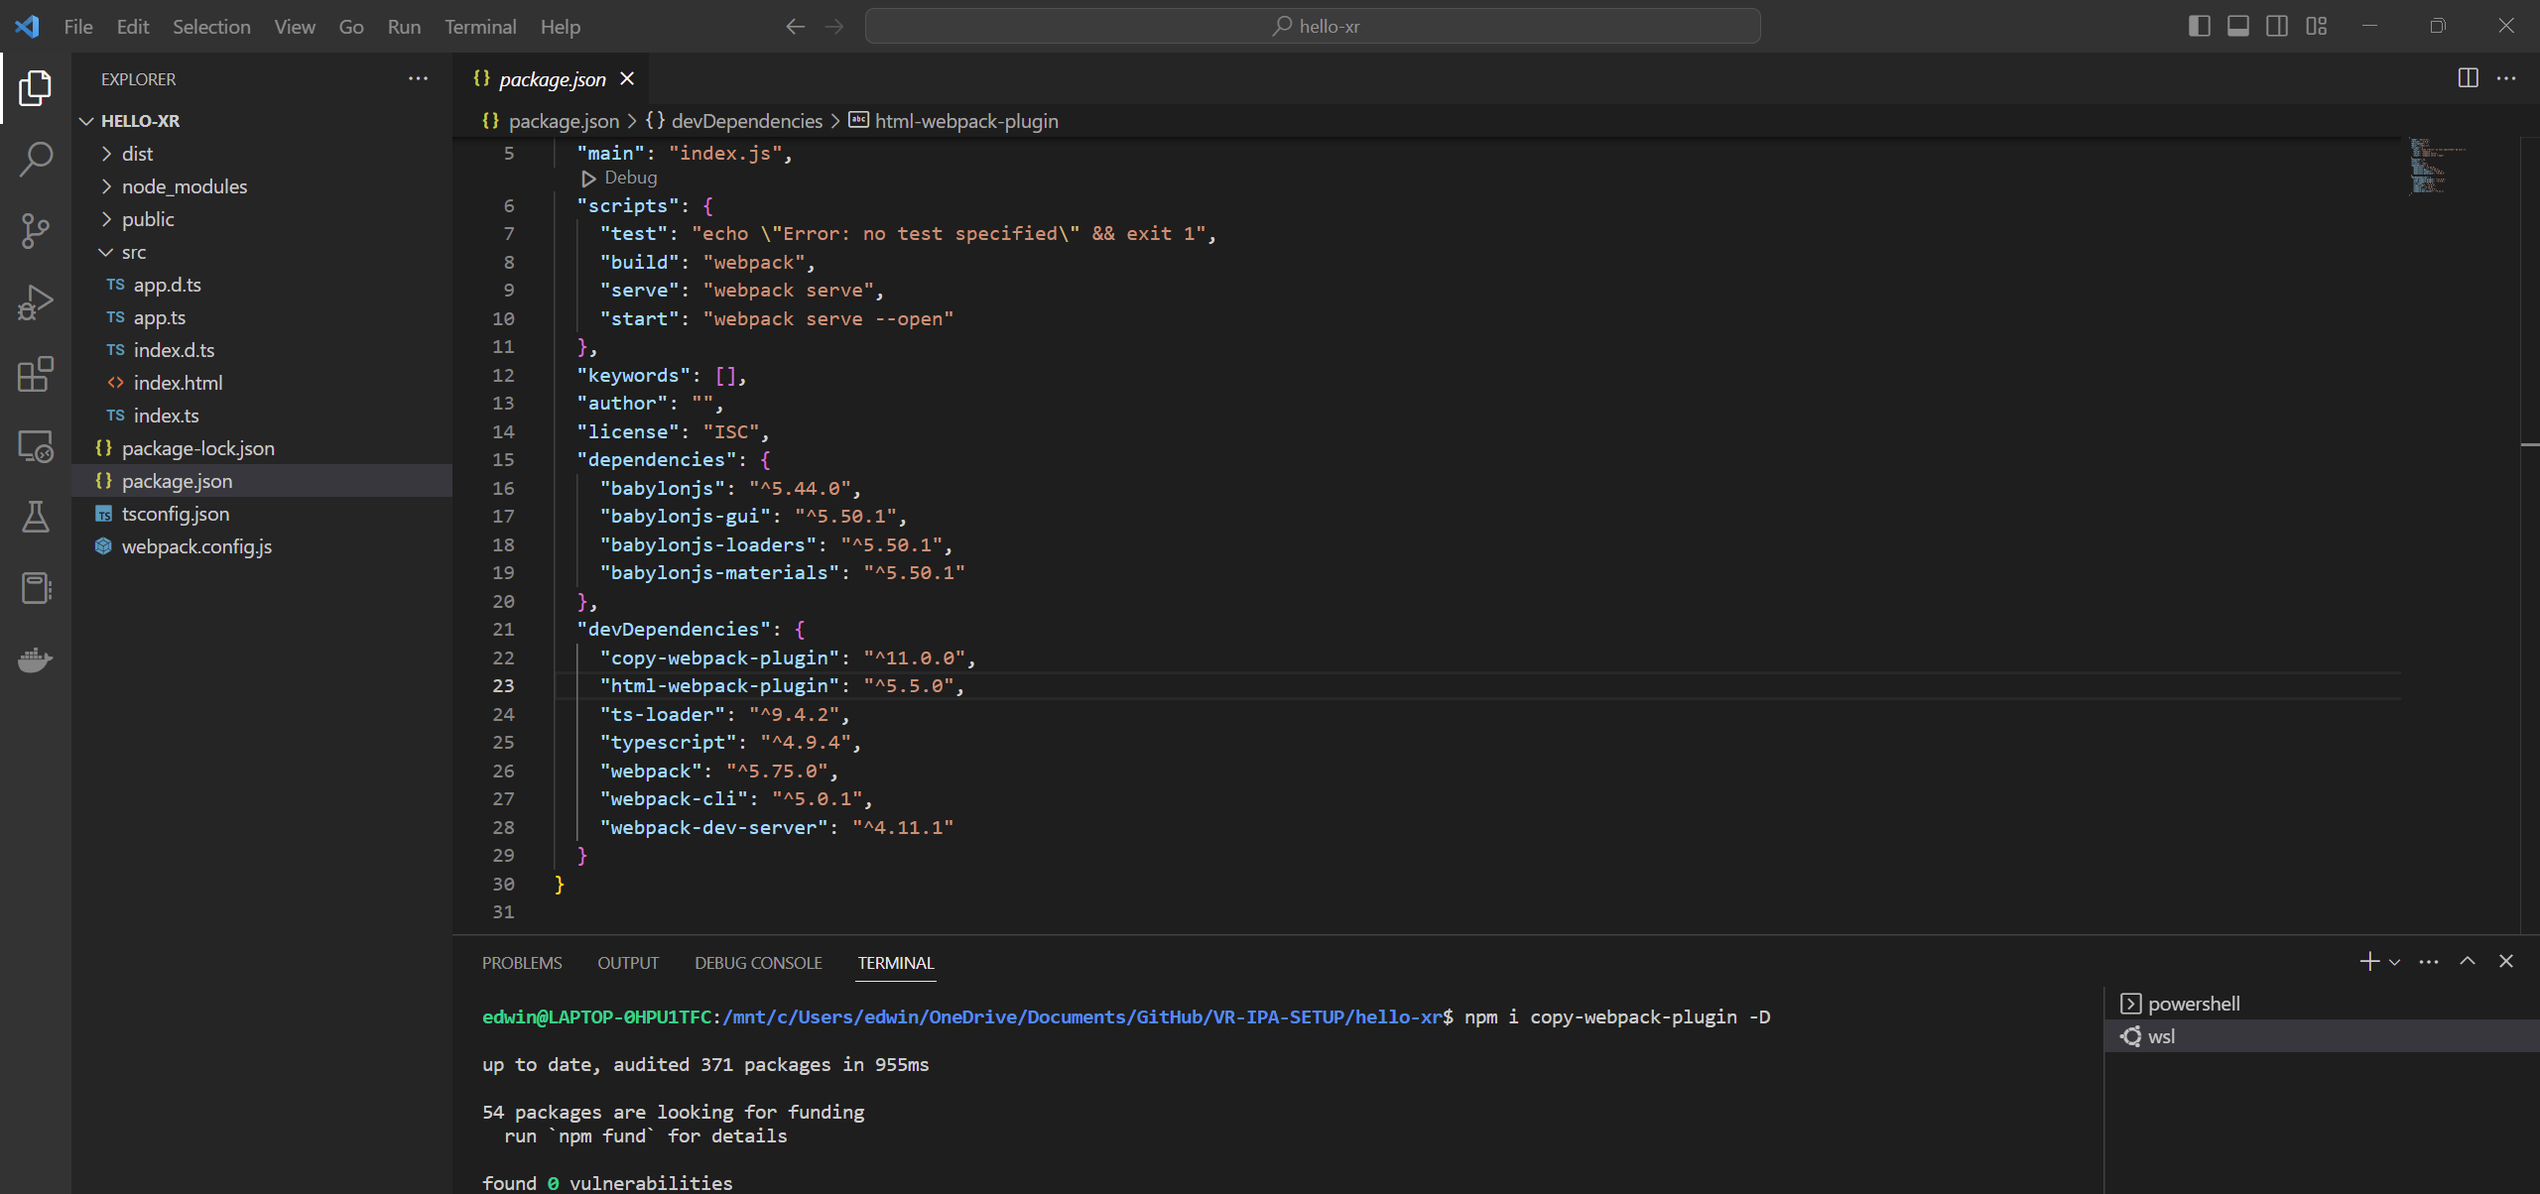

**webpack.json**

Add the following codes:

const CopyPlugin = require('copy-webpack-plugin')

Here:

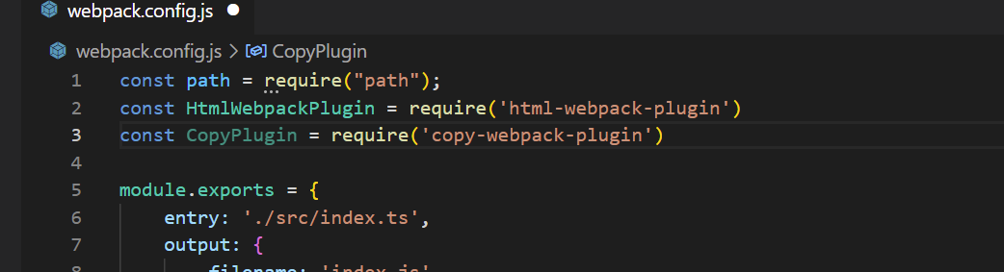

Add the following codes:

new CopyPlugin({

            patterns: [

                { from: path.resolve(__dirname, 'public')}

            ]

        }),

Here:

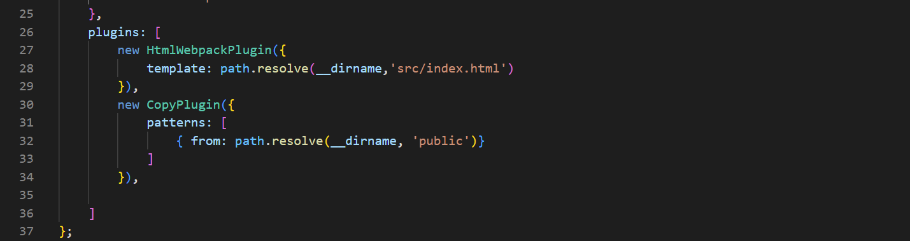

Enter the following commands in WSL (to Rebuild the project):

npm run build

You should be able to see your assets folder from your public folder copied to your dist folder.

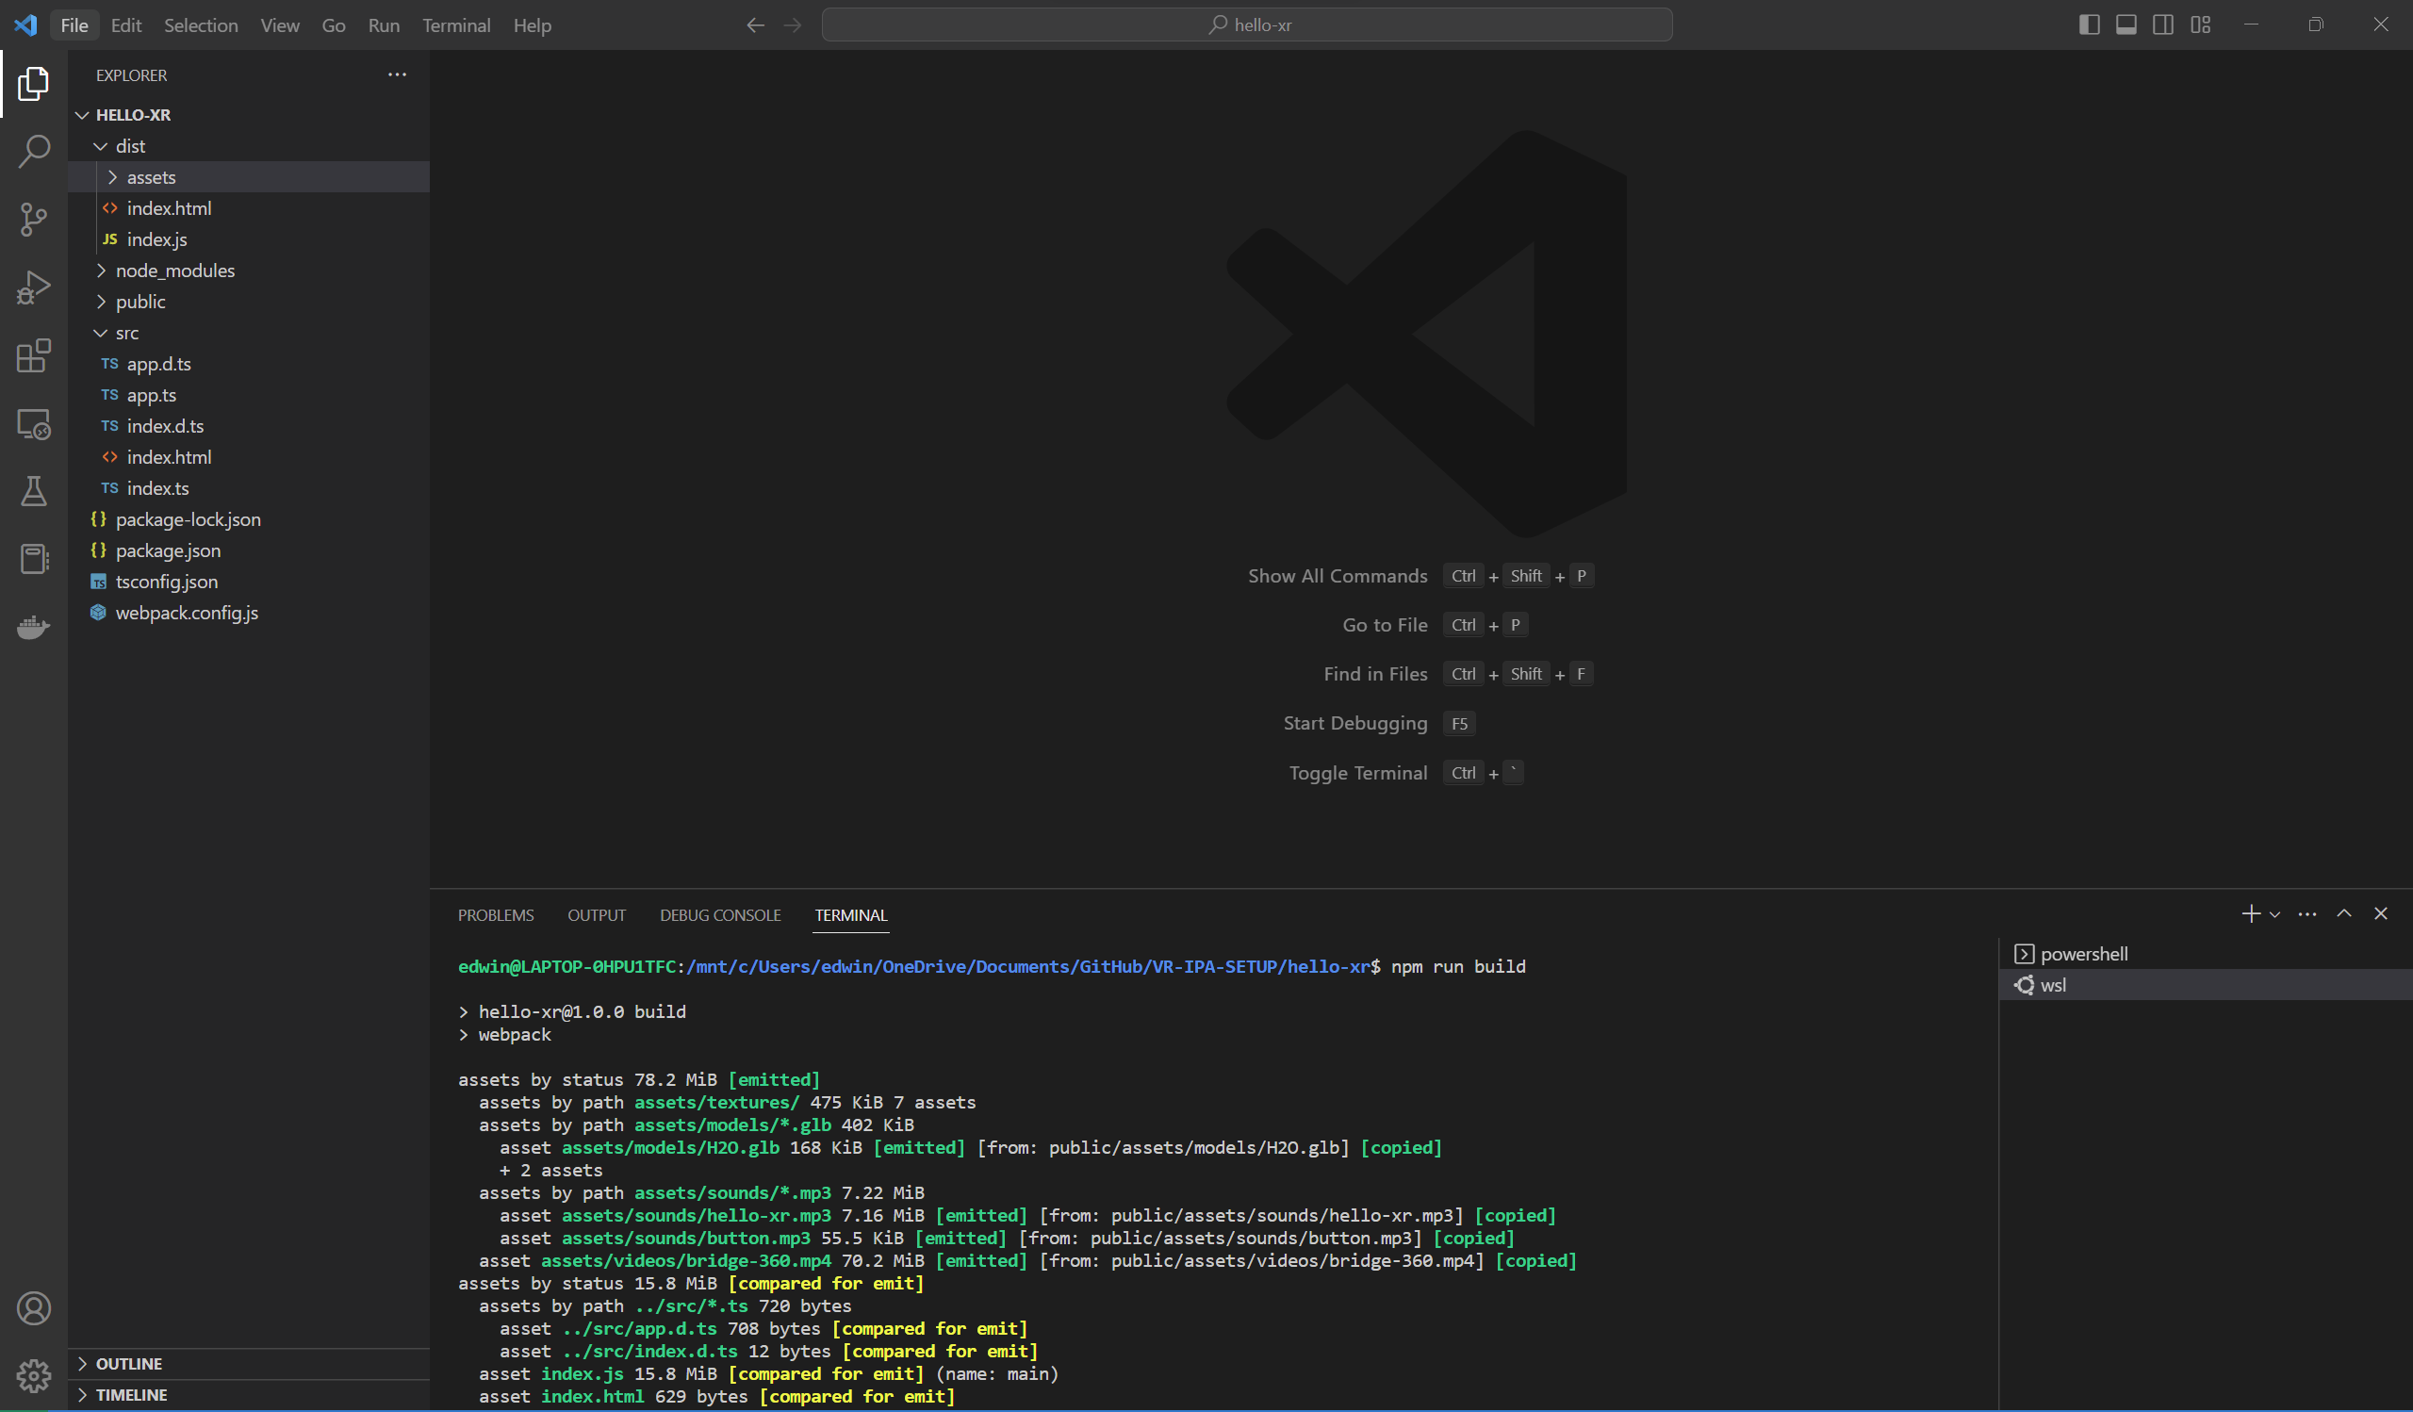

## Deploying to Production Server (instead of Dev Server)

Enter the following commands in WSL:

cd dist

python3 -m http.server

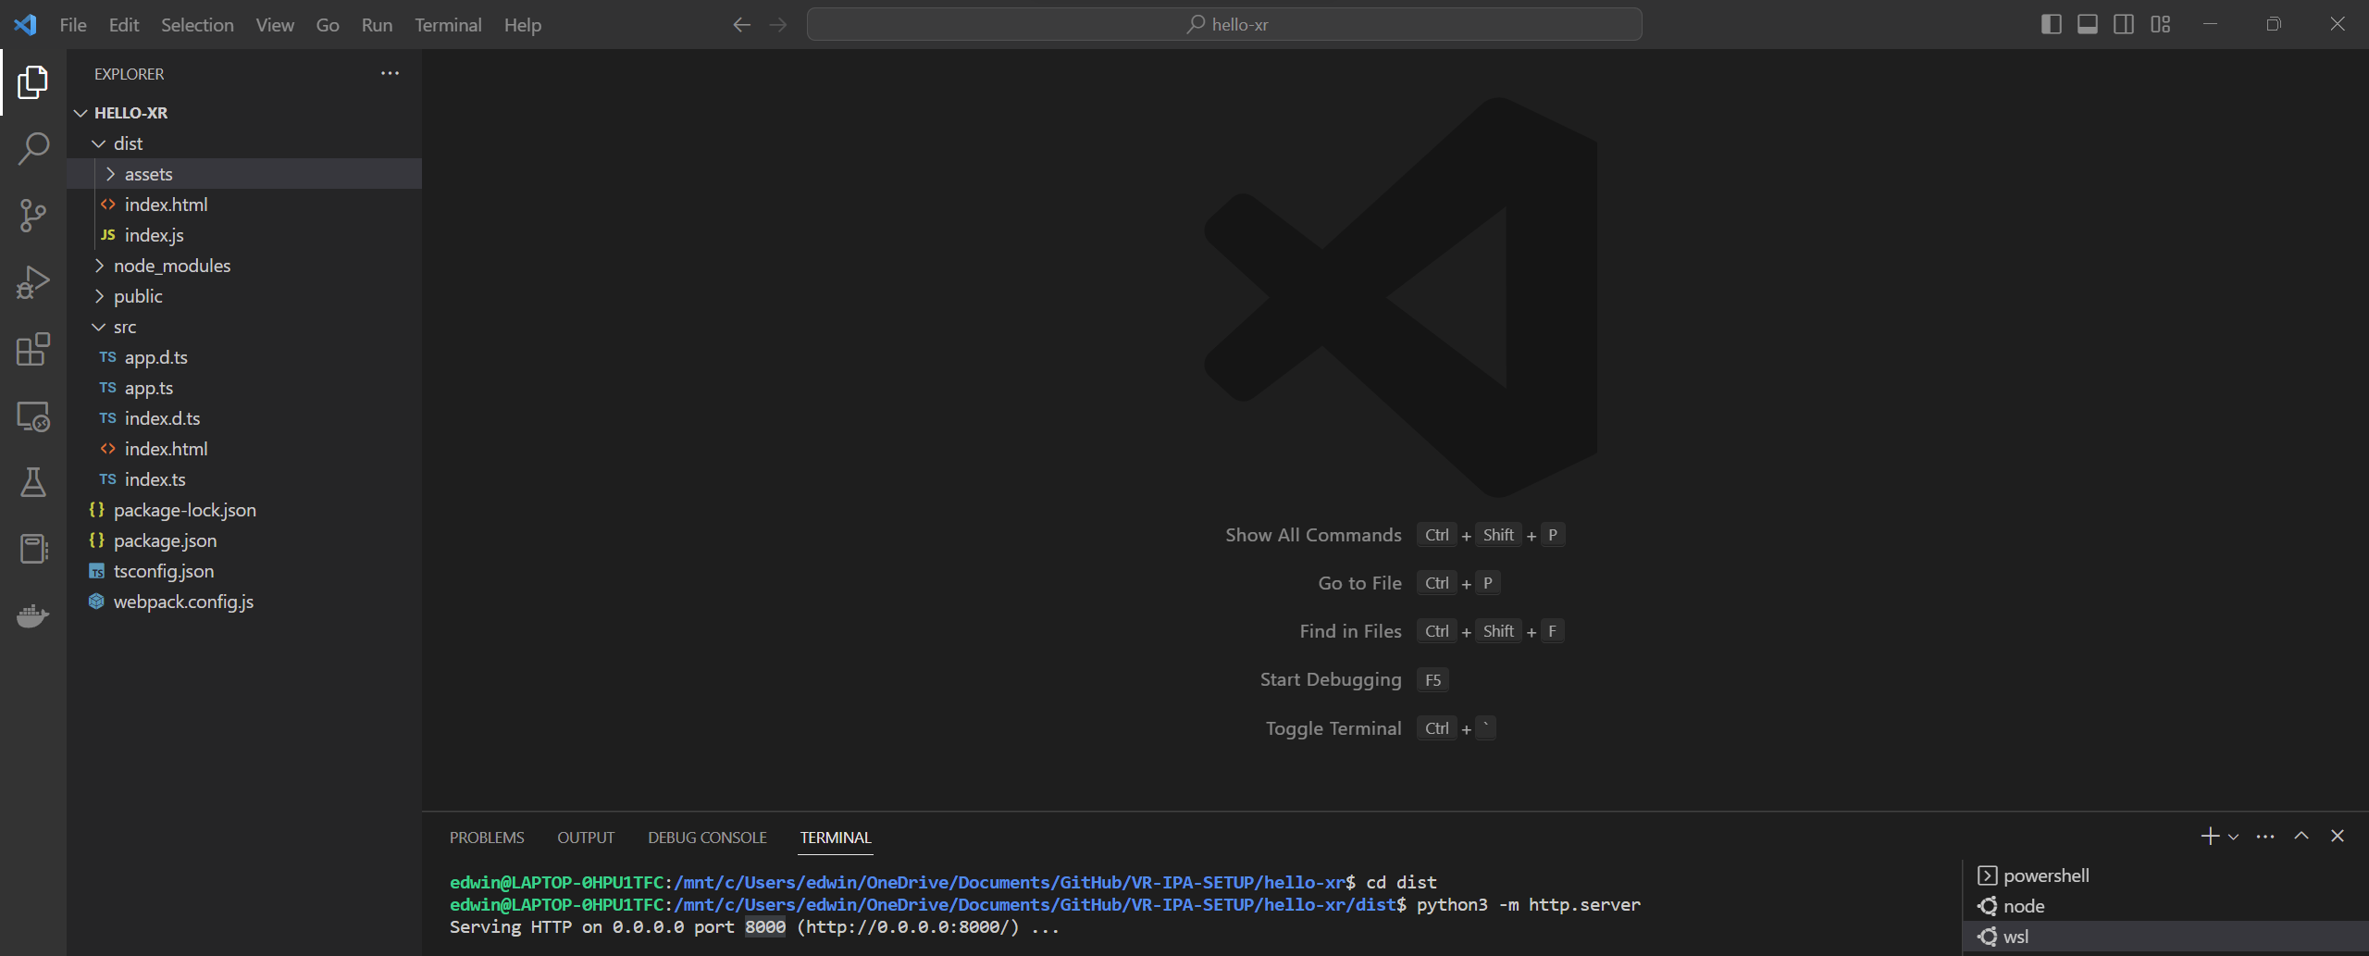

Go to localhost:8000 in your chrome browser.

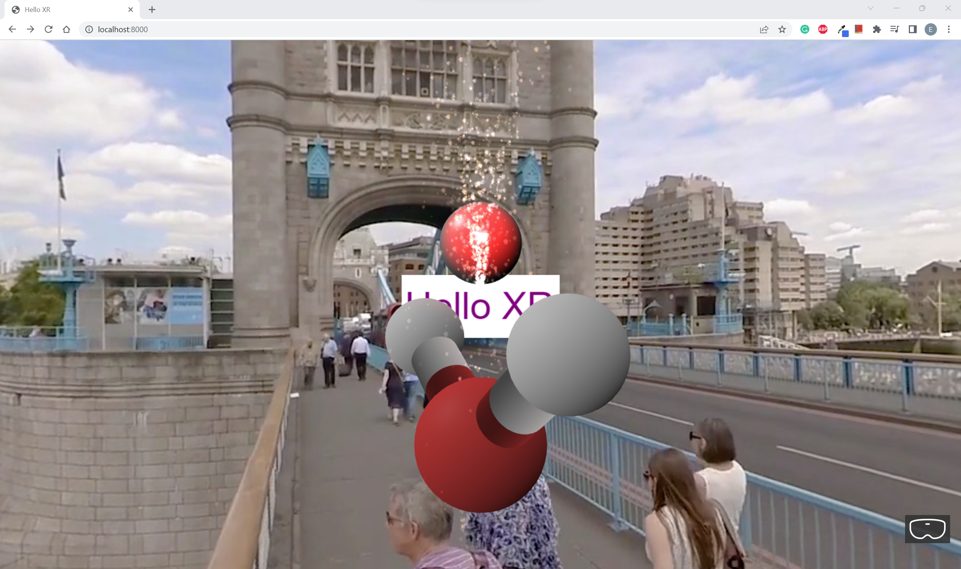

You should be able to see the Web App working fine on the production server.

## Refactoring codes

**tsconfig.json**

Comment out the following codes:

//"declaration": true,

Here:

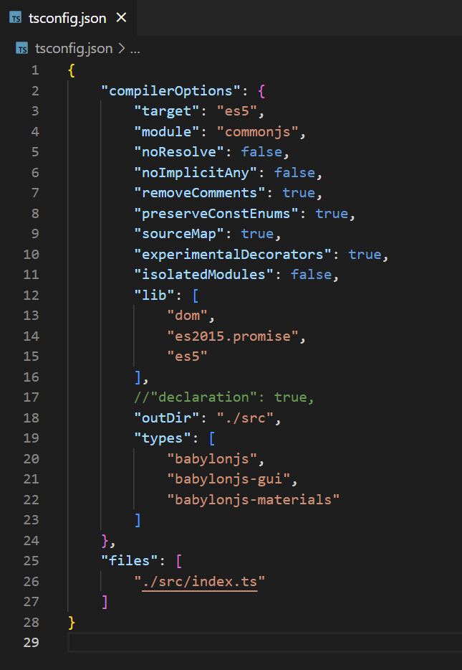

**app.ts**

Under createScene():

Comment out the following codes:

//this.createVideoSkyDome(scene);

//this.addSounds(scene)

Change this code to:

sphere.position.y = -0.5

Change these codes to:

scene.createDefaultCameraOrLight()

//this.createCamera(scene)

//this.createLights(scene)

*Component based architecture*

### Text Component

Enter the following commands in WSL:

cd src

mkdir -p components/meshes

cd components/meshes

touch index.ts

touch text-plane.ts

You should be able to see "components\meshes" folders added to your "src" folder.

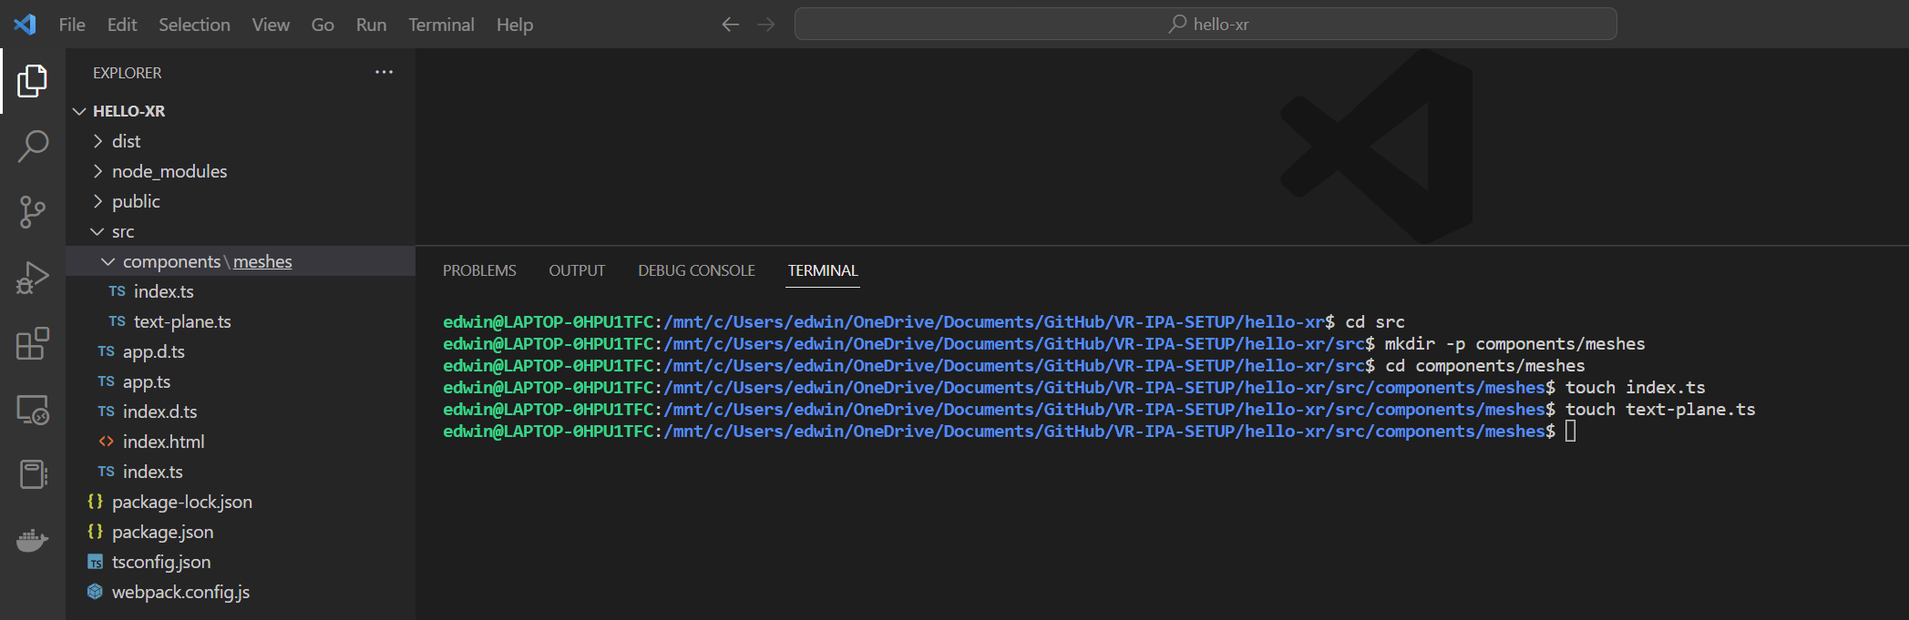

Go to **components\meshes\index.ts** and add the following codes:

export * from './text-plane'

Go to **components\meshes\text-plane.ts** and add the following codes:

import { Mesh, MeshBuilder, Scene } from "babylonjs";

import { AdvancedDynamicTexture, TextBlock } from "babylonjs-gui";

export class TextPlane {

  public mesh: Mesh

  public textBlock: TextBlock;

  constructor(

    name: string,

    width: number,

    height: number,

    x: number,

    y: number,

    z: number,

    text: string,

    backgroundColor: string,

    textColor: string,

    fontSize: number,

    scene: Scene

  ) {

    const textPlane = MeshBuilder.CreatePlane(name + " text plane", {

      width: width,

      height: height,

    });

    textPlane.position.set(x, y, z);

    const planeTexture = AdvancedDynamicTexture.CreateForMesh(

      textPlane,

      width * 100,

      height * 100,

      false

    );

    planeTexture.background = backgroundColor;

    const planeText = new TextBlock(name + " plane text");

    planeText.text = text;

    planeText.color = textColor;

    planeText.fontSize = fontSize;

    planeTexture.addControl(planeText);

    this.mesh = textPlane

    this.textBlock = planeText

  }

}

**app.ts**

Add the following codes:

import { TextPlane } from "./components/meshes"

Here:

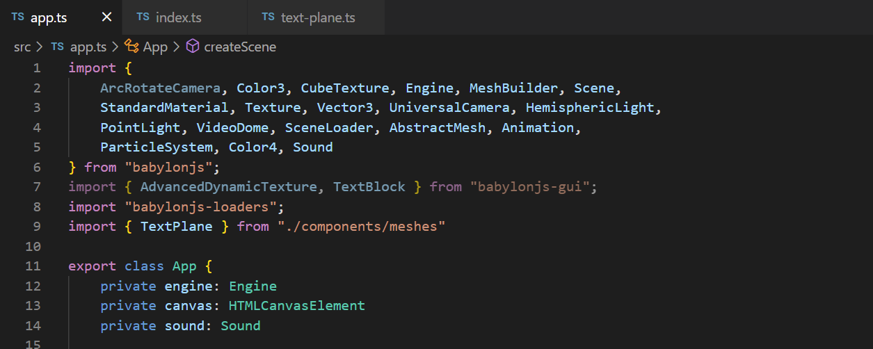

Replace CreateText(scene:Scene) with the following codes:

createText(scene:Scene)

    {

        const helloPlane = new TextPlane(

            "hello plane",

            3,

            1,

            0,

            2,

            5,

            "Hello XR",

            "white",

            "purple",

            60,

            scene

        )

        helloPlane.textBlock.onPointerUpObservable.add(evtData => {

            alert('Hello Text at: \n x: ' + evtData.x + ' y:' + evtData.y)

        })

        helloPlane.textBlock.onPointerDownObservable.add(() => {

            this.sound.play()

        })

    }

Here:

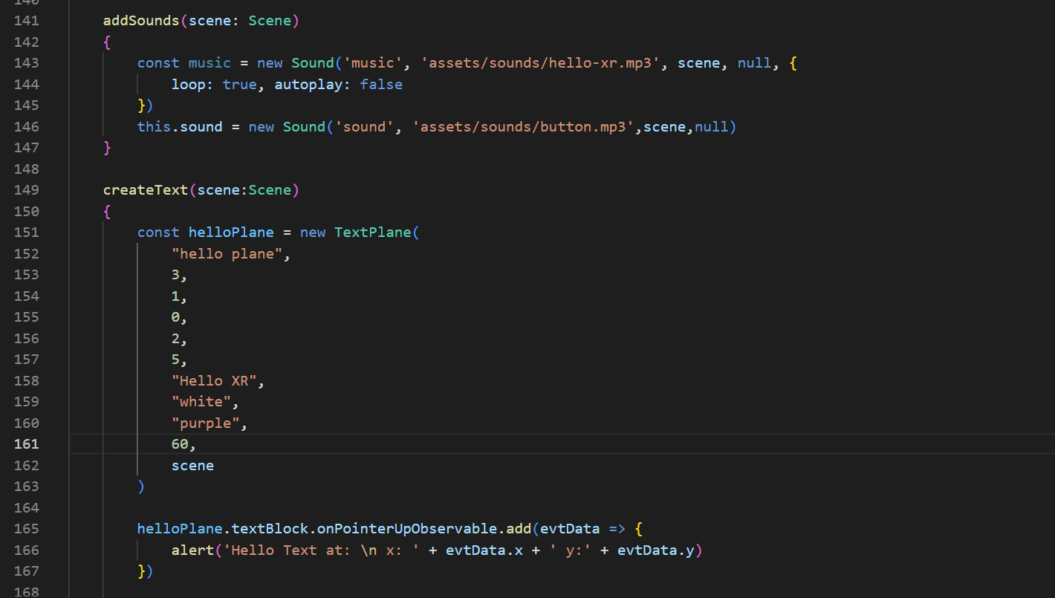

### Mesh Component

Enter the following commands in WSL:

touch hello-mesh.ts

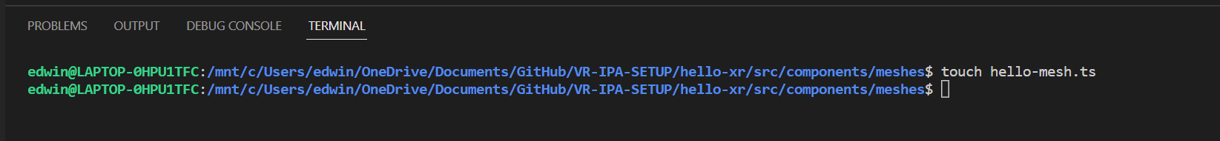

You should be able to see "hello-mesh.ts" file added to your "components\meshes" folder.

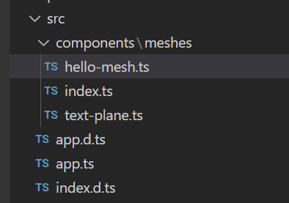

Change these codes under createScene() to:

//simple sphere

        const sphere = MeshBuilder.CreateSphere('sphere', { diameter: 1.3 }, scene)

        sphere.position.y = -0.5

        sphere.position.z = 5

        //hello sphere

        const helloSphere = new HelloSphere("hello sphere", {diameter: 1}, scene)

        helloSphere.position.set(0, 1, 5)

Go to **components\meshes\index.ts** and add the following codes:

export * from './hello-mesh'

Go to **components\meshes\hello-mesh.ts** and add the following codes:

import {

  AbstractMesh,

  Mesh,

  MeshBuilder,

  Scene,

  StandardMaterial,

} from "babylonjs";

import { TextPlane } from "./text-plane";

export interface HelloMesh {

  scene: Scene;

  mesh: Mesh;

  label: TextPlane;

}

export class HelloSphere extends AbstractMesh implements HelloMesh {

  scene: Scene;

  mesh: Mesh;

  label: TextPlane;

  constructor(name: string, options: { diameter: number }, scene: Scene) {

    super(name, scene);

    this.scene = scene;

    this.mesh = MeshBuilder.CreateSphere("hello sphere mesh", options, scene);

    this.mesh.material = new StandardMaterial("hello sphere material", scene);

    this.addChild(this.mesh);

    this.label = new TextPlane(

      "hello sphere label",

      1.5,

      1,

      0,

      options.diameter / 2 + 0.2,

      0,

      "hello sphere",

      "purple",

      "white",

      25,

      scene

    );

    this.addChild(this.label.mesh);

  }

}

**Check**

You should see 2 Spheres rendered in your web app.

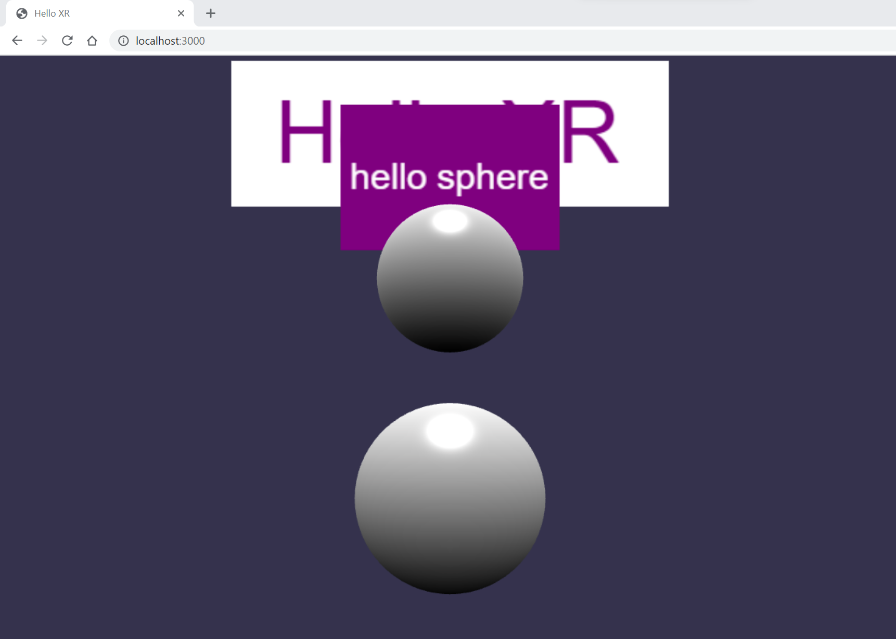

## Creating Ground Plane

**app.ts**

Add the following codes:

 //ground

    const groundMaterial = new StandardMaterial("ground material",  scene)

    groundMaterial.backFaceCulling = true

    groundMaterial.diffuseTexture = new Texture('assets/textures/grass.png', scene)

    const ground = MeshBuilder.CreateGround("ground", {width: 12, height: 12}, scene)

    ground.material = groundMaterial

    ground.position.set(0, -1, 8)

Here:

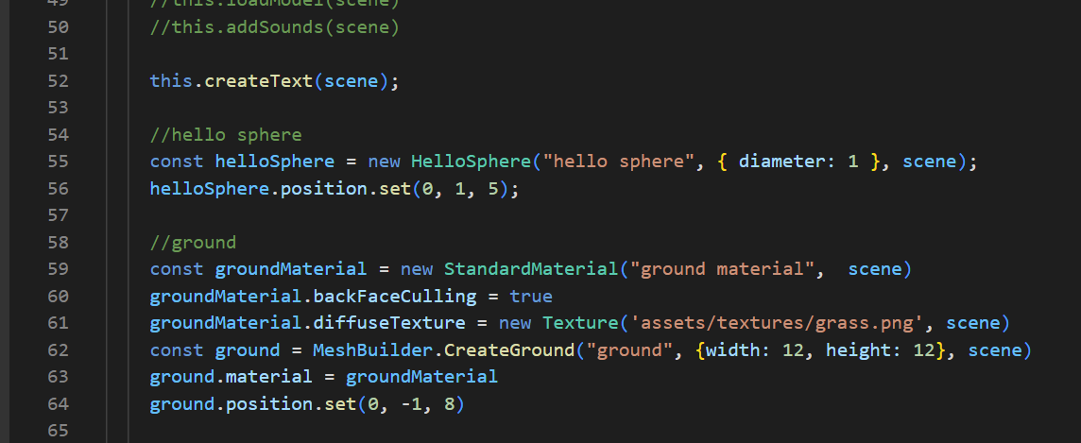

Change these codes to:

scene.createDefaultCameraOrLight(false, true, true)

## Interactions (Moving Sphere)

**app.ts**

Add the following codes:

 //interactions

    //use behaviors

    const pointerDragBehavior = new PointerDragBehavior({

      dragPlaneNormal: Vector3.Up(),

    });

    sphere.addBehavior(pointerDragBehavior);

Here:

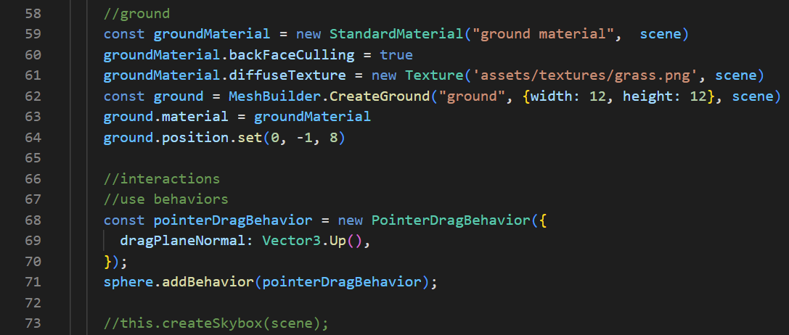

**Check**

You should be able to move the Sphere closest to you by Left/Middle/Right clicking and dragging the Sphere around.

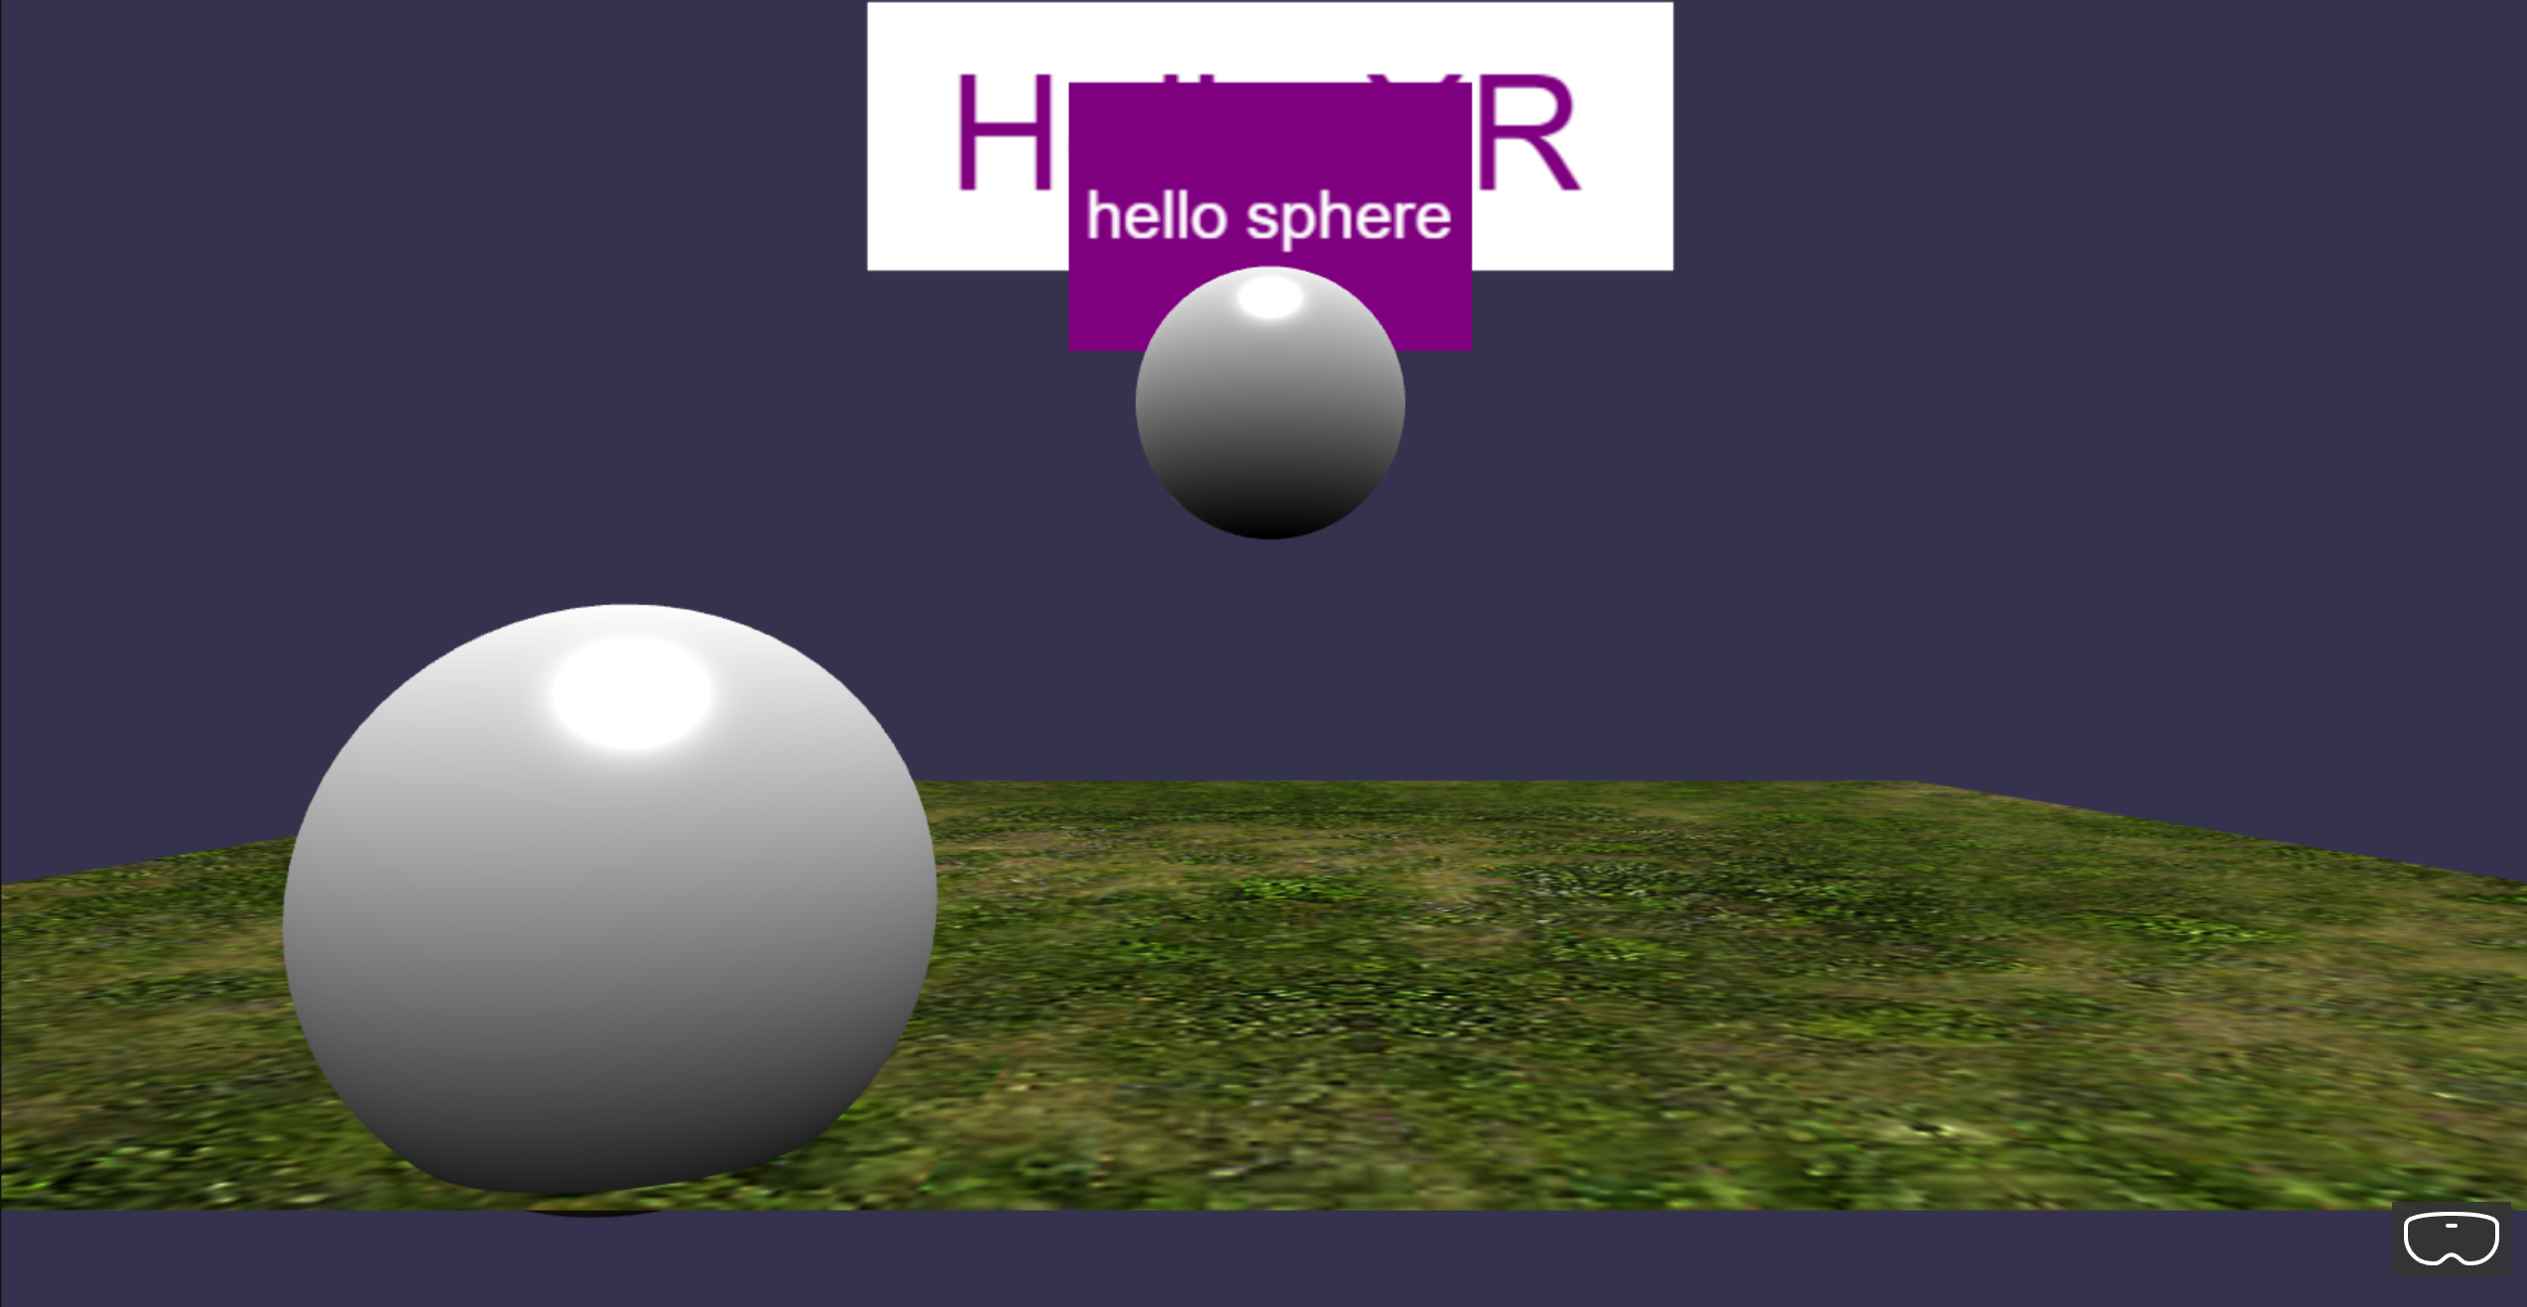

## Observables (Console log)

**app.ts**

Add the following codes:

pointerDragBehavior.onDragStartObservable.add(evtData=>{

      console.log("drag start: pointer id -" + pointerDragBehavior,

      evtData.pointerId)

      console.log(evtData)

    })

Here:

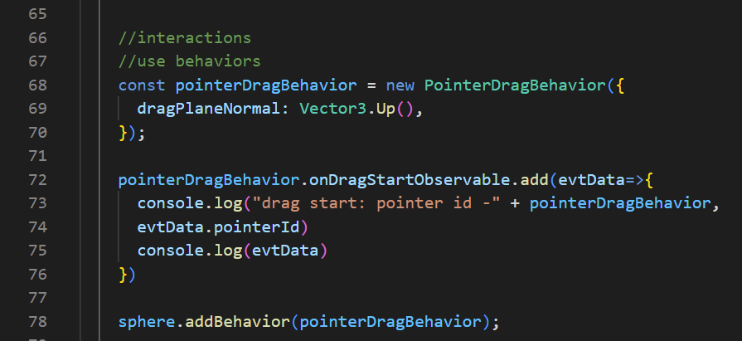

**Check**

You should be able to see “drag start: …” printed in the Console tab whenever you select and drag the Sphere around.

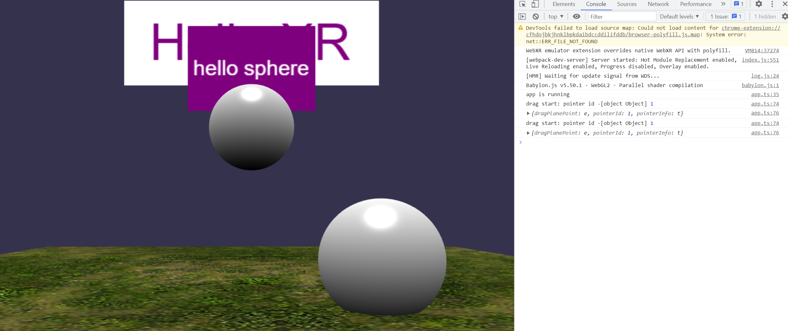

**app.ts**

Add the following codes:

helloSphere.sayHello("this a test.")

Here:

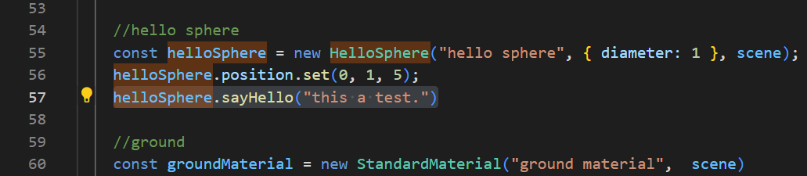

Hello-mesh.ts

Add the following codes:

sayHello(message?: string): void

Here:

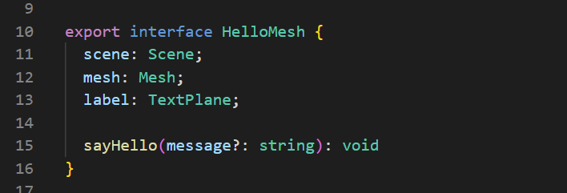

Add the following codes:

 sayHello(message?: string): void{

    console.log("message from hello sphere: " + message)

  }

Here:

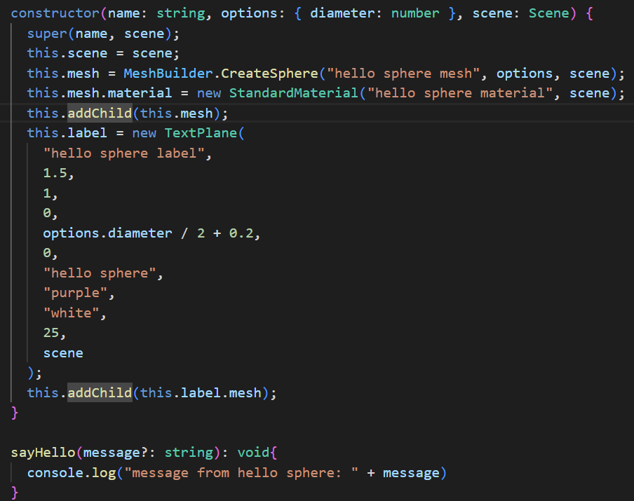

**Check**

You should be able to see “message from hello sphere: this a test.” printed in the Console tab when you start the web app.

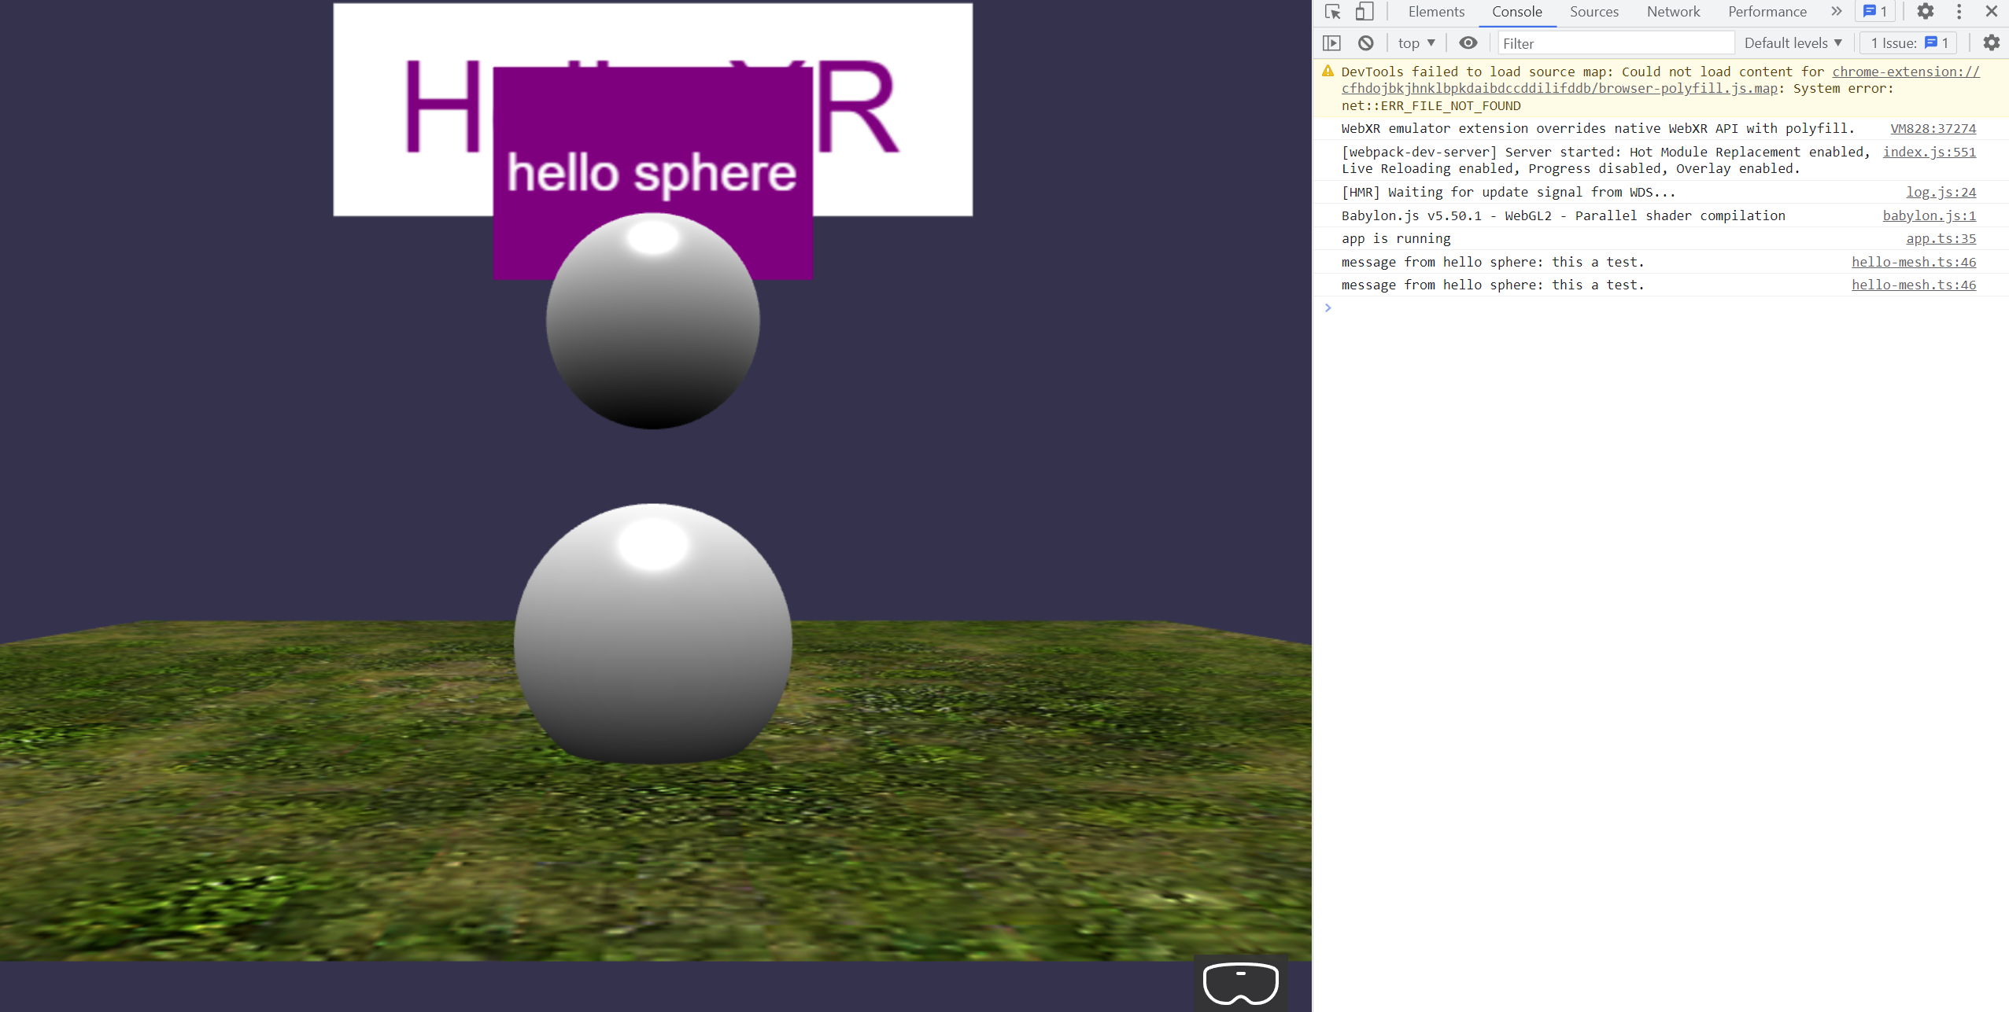

## Action Behaviours

### Mouse Input

**hello-mesh.ts**

Add the following codes:

this.initActions();

Here:

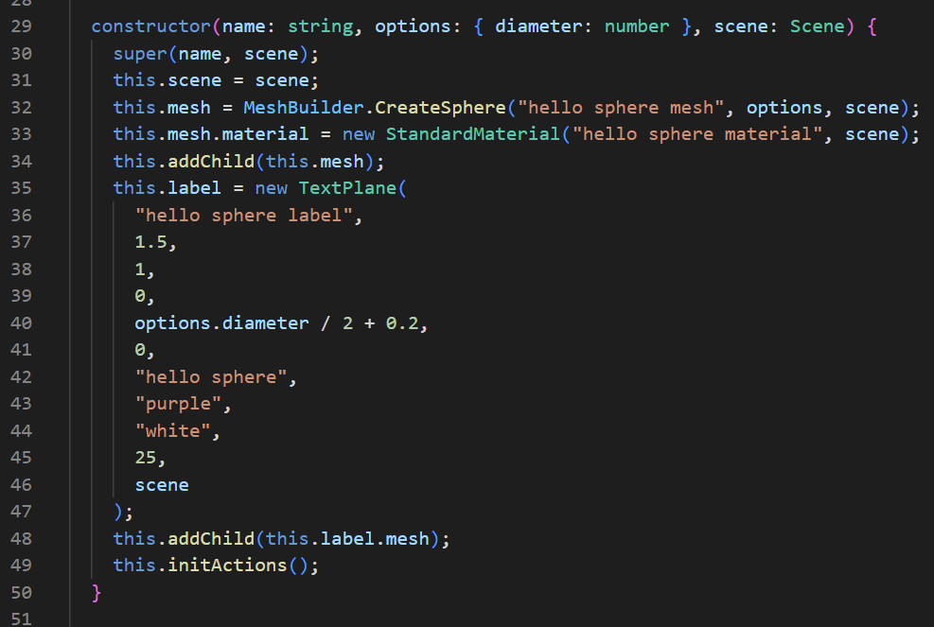

Add the following codes:

private initActions() {

    const actionManager = (this.actionManager = new ActionManager(this.scene));

    actionManager.isRecursive = true;

    const light = this.scene.getLightById("default light");

    //Switch ON/OFF lights

    actionManager

      .registerAction(

        new InterpolateValueAction(

          ActionManager.OnPickDownTrigger,

          light,

          "diffuse",

          Color3.Black(),

          1000

        )

      )

      .then(

        new InterpolateValueAction(

          ActionManager.OnPickDownTrigger,

          light,

          "diffuse",

          Color3.White(),

          1000

        )

      );

    //Scale up sphere

    actionManager.registerAction(

      new InterpolateValueAction(

        ActionManager.OnPickDownTrigger,

        this,

        "scaling",

        new Vector3(2, 2, 2),

        1000,

        new PredicateCondition(actionManager, () => {

          return light.diffuse.equals(Color3.Black());

        })

      )

    );

    //Collision

    const otherMesh = this.scene.getMeshById("sphere");

    actionManager.registerAction(

      new SetValueAction(

        {

          trigger: ActionManager.OnIntersectionEnterTrigger,

          parameter: {

            mesh: otherMesh,

            usePreciseIntersection: true,

          },

        },

        this.mesh.material,

        "wireframe",

        true

      )

    );

  }

Here: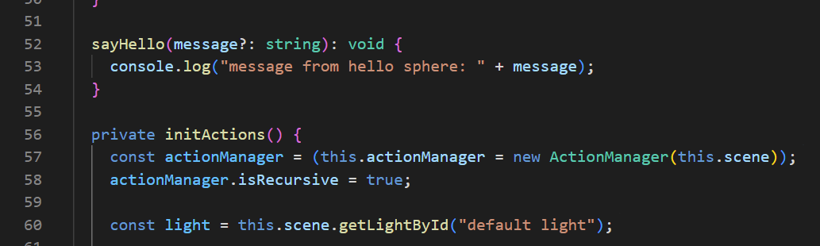

**app.ts**

Add the following codes:

const helloSphereDragBehavior = new PointerDragBehavior({

      dragPlaneNormal: Vector3.Backward(),

    });

    helloSphere.addBehavior(helloSphereDragBehavior);

Here:

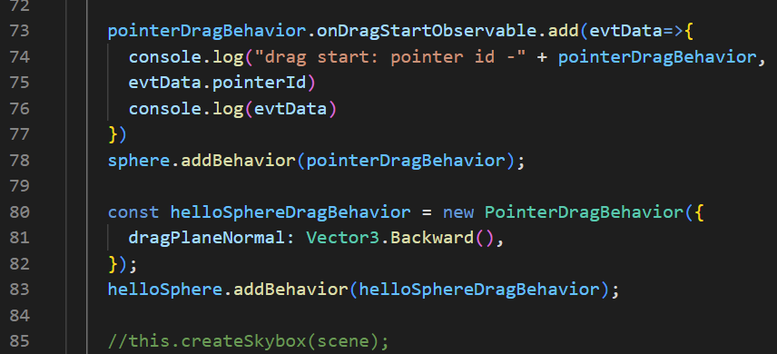

**Check**

When you click on the “helloSphere” Object, you should be able to see the surroundings turning black.

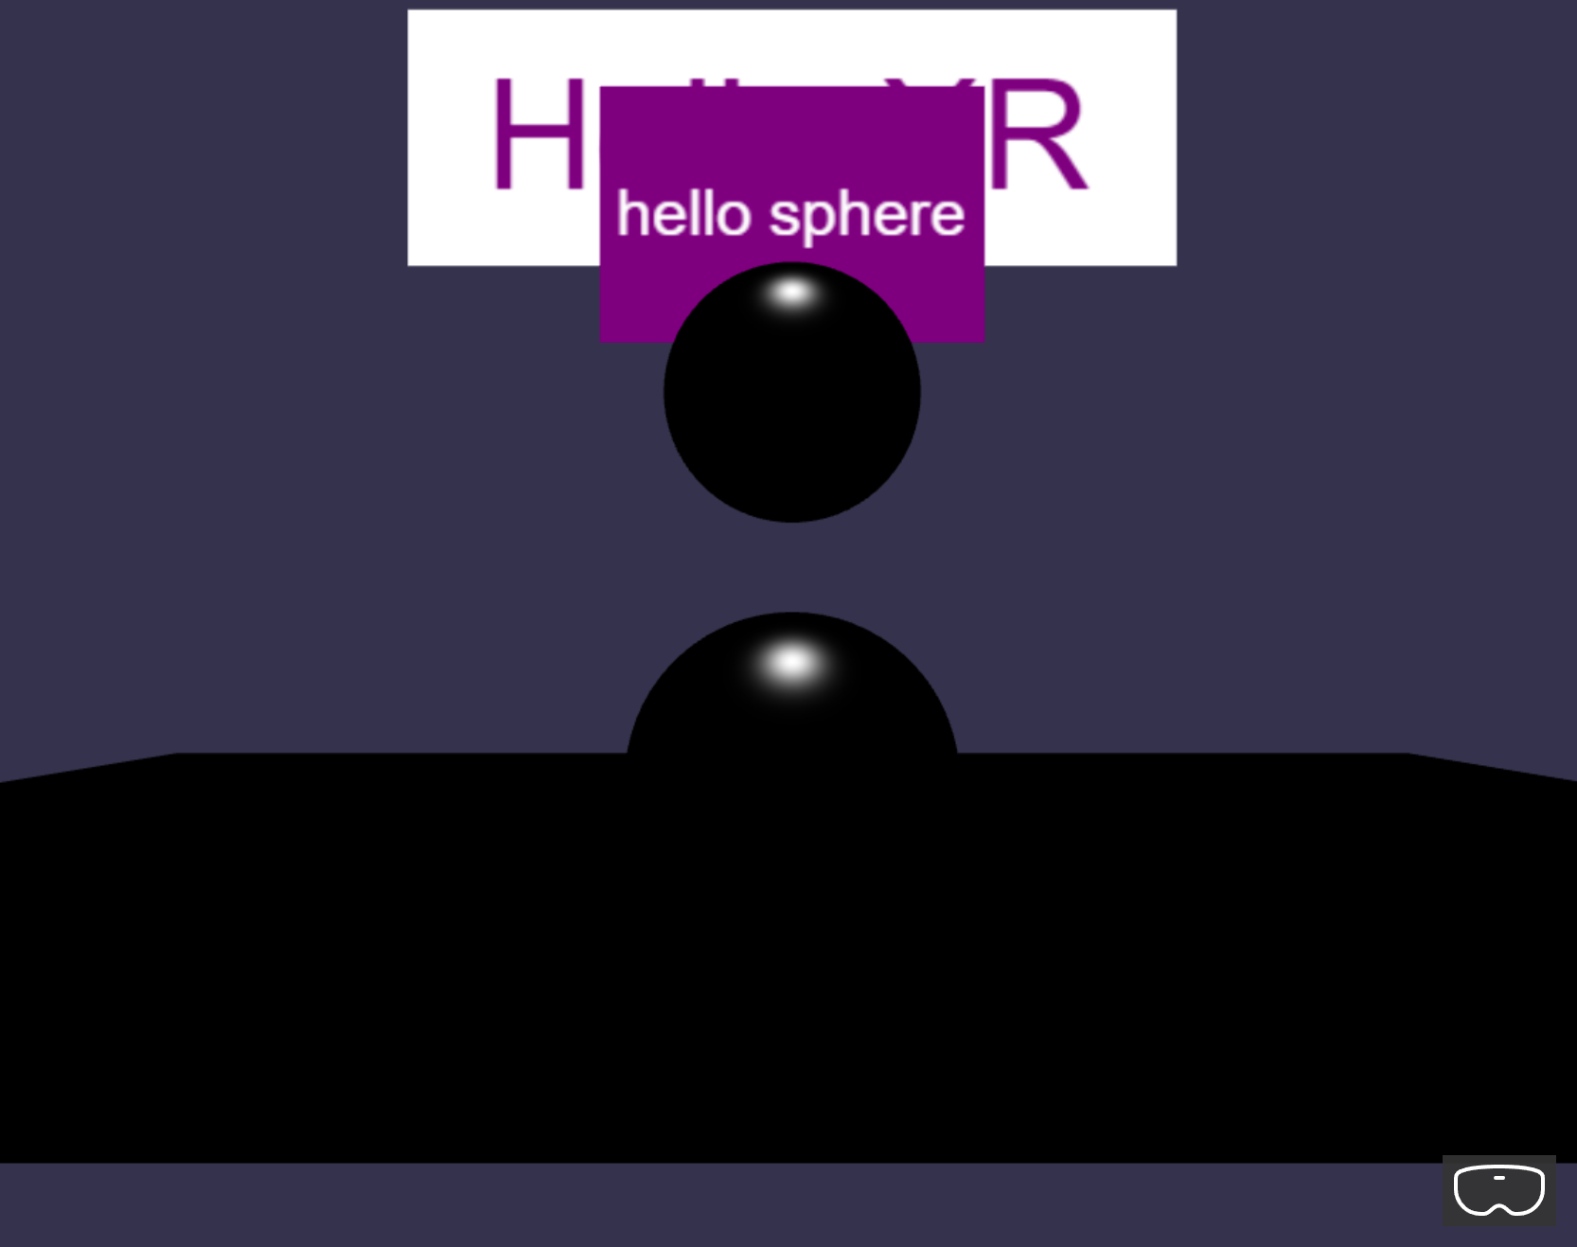

When you click on the “helloSphere” Object again, the lights will turn back on, and the “helloSphere” Object will begin to gradually expand to 2 times its original size.

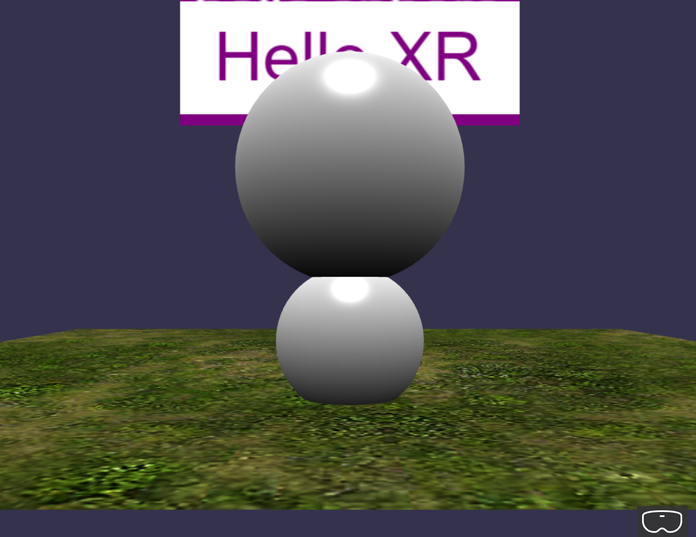

When you drag the “helloSphere” Object to collide with the “sphere” Object, the “helloSphere” Object will turn into a wireframe Sphere.

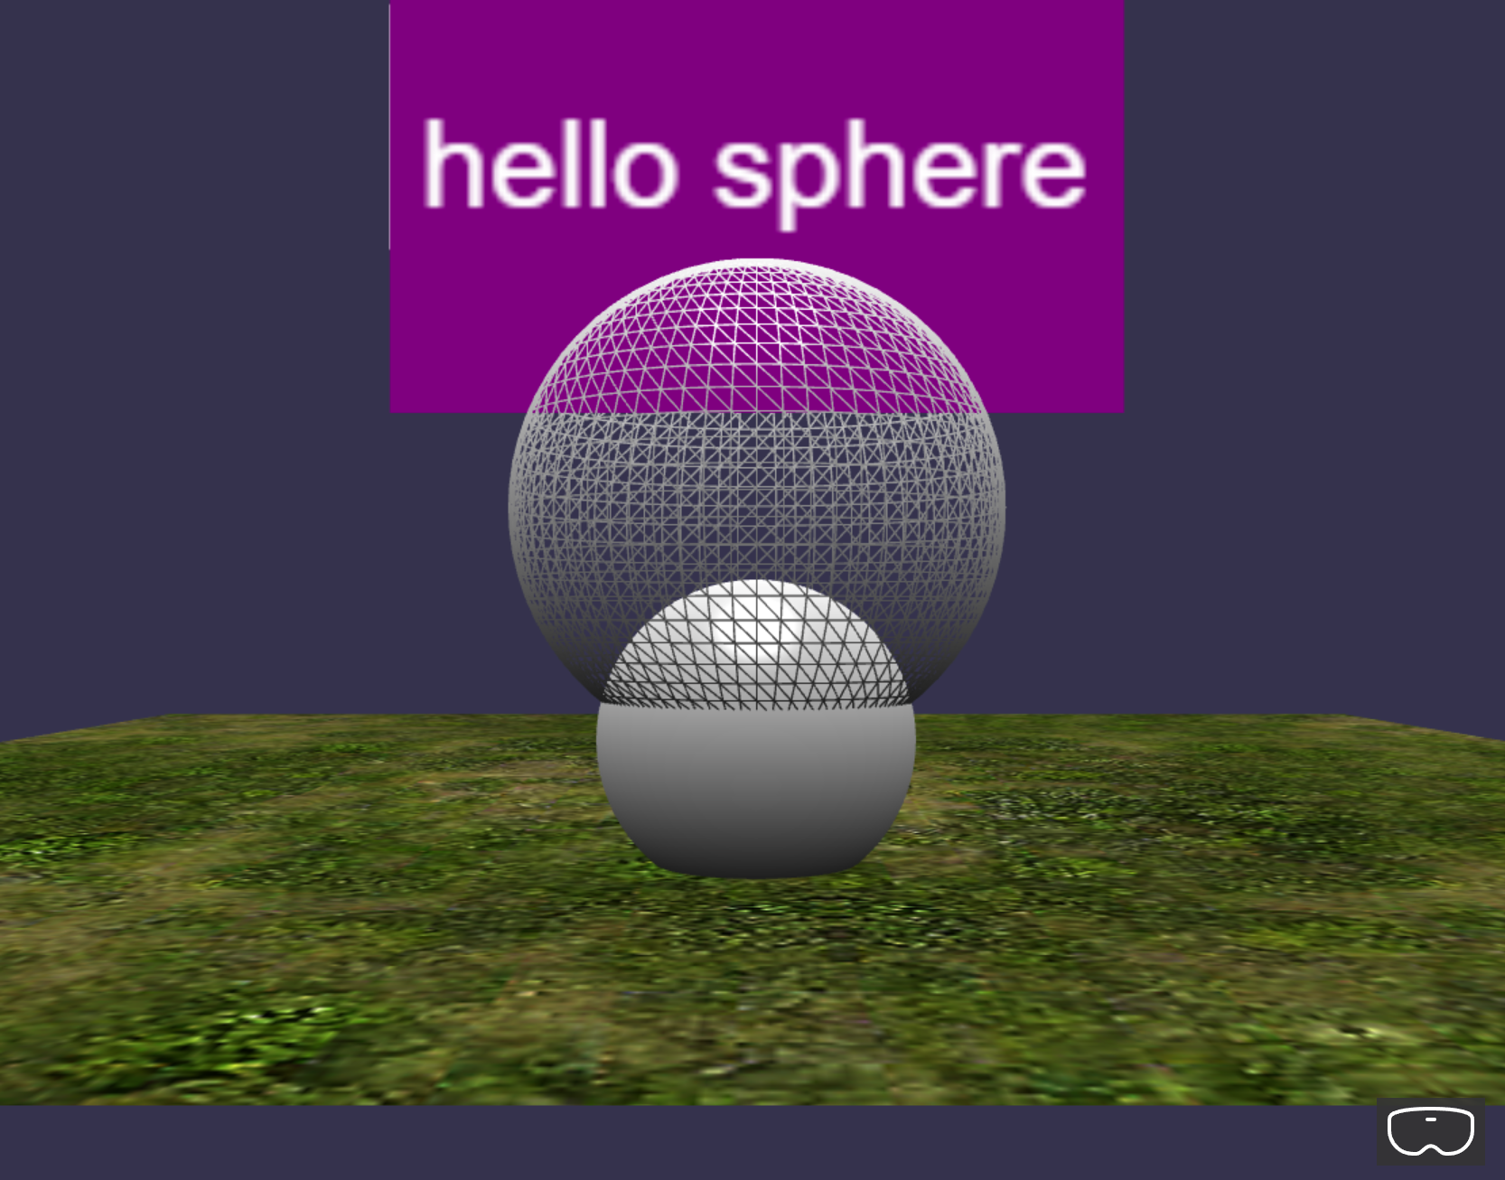

### Keyboard Input

**app.ts**

Add the following codes:

scene.actionManager = new ActionManager(scene)

Here: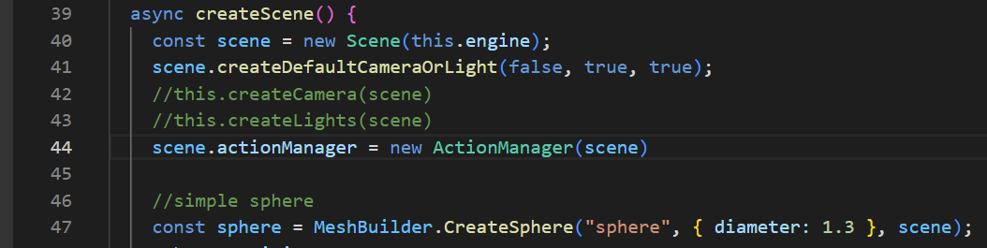

**hello-mesh.ts**

Add the following codes:

//Reset sphere

    this.scene.actionManager.registerAction(

      new ExecuteCodeAction(

        {

          trigger: ActionManager.OnKeyUpTrigger,

          parameter: "r",

        },

        () => {

          this.scaling.setAll(1);

          this.mesh.material.wireframe = false;

          console.log("r was pressed: reset " + this.name);

        }

      )

    );

Here:

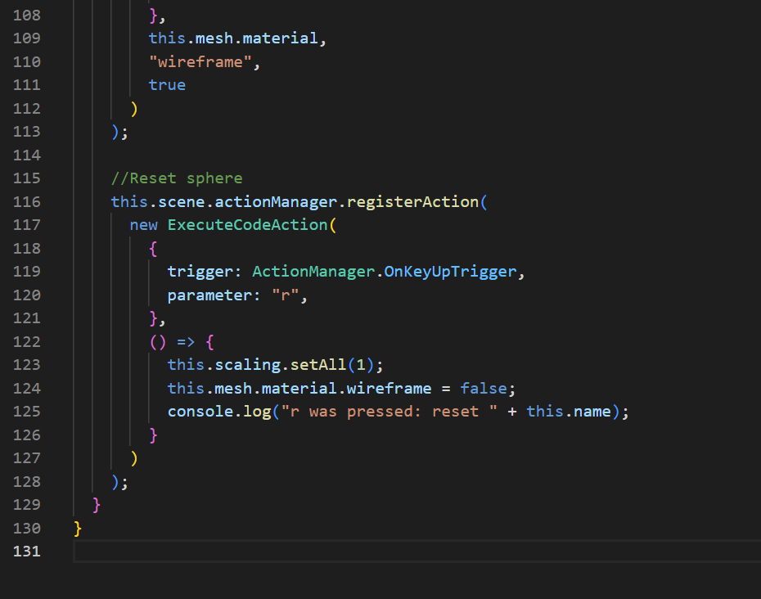

**Check**

When you press the “R” Key, the previous effects that the “helloSphere” Object is having will reset back to its original state.

Before:

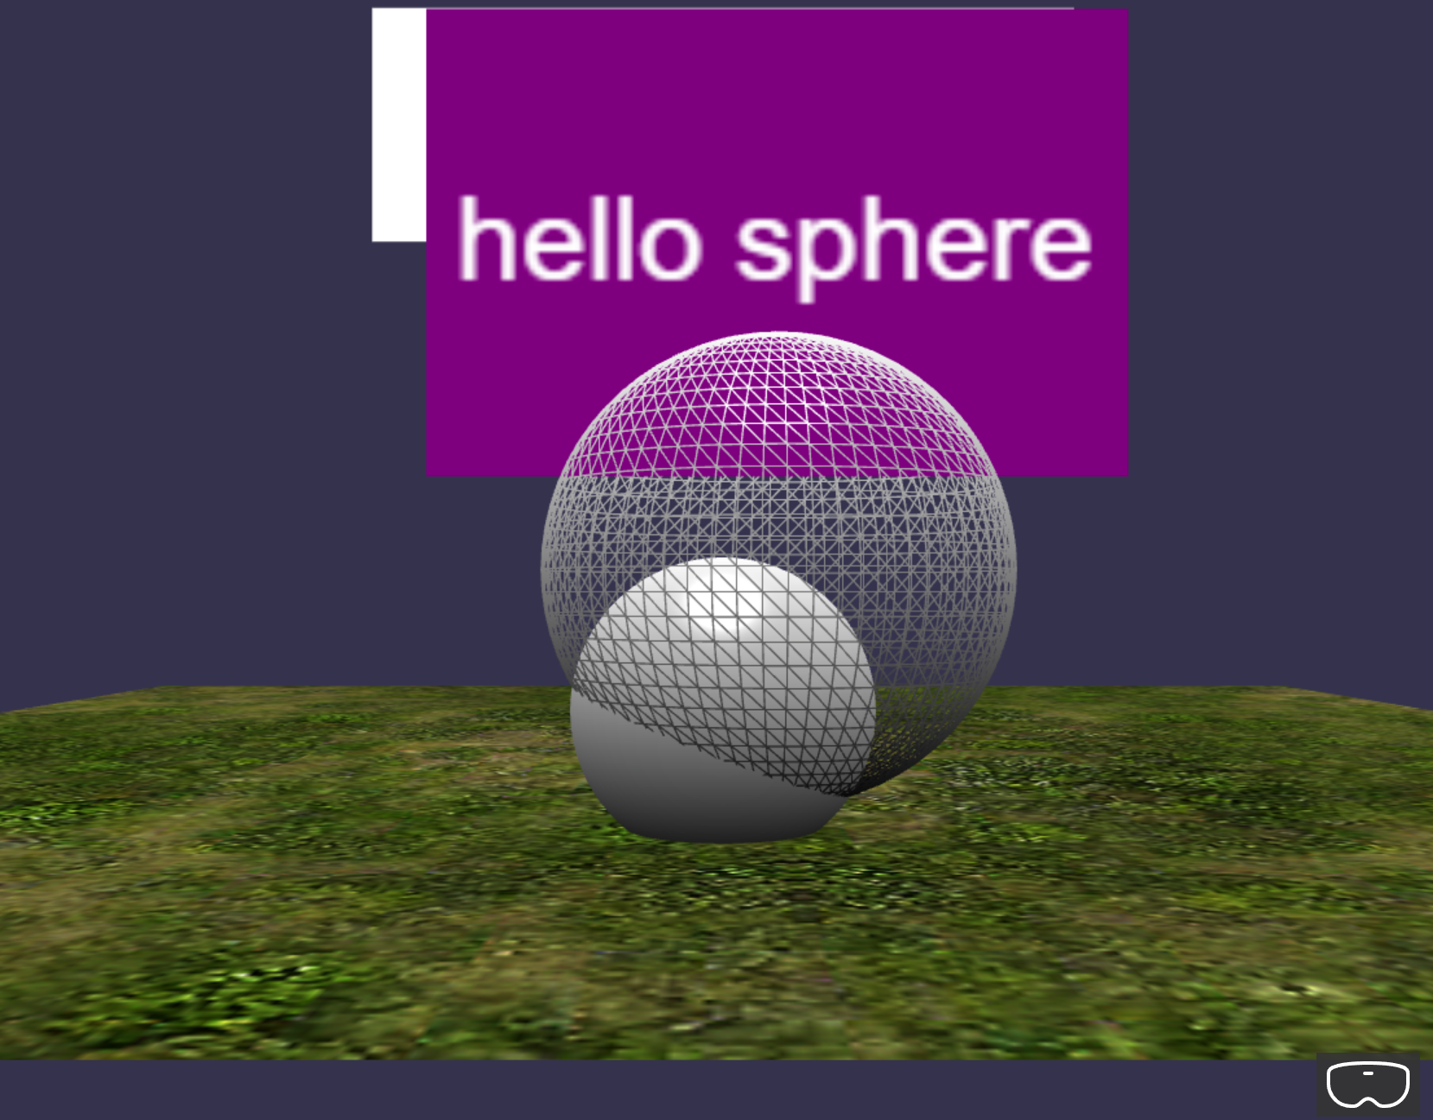

After:  
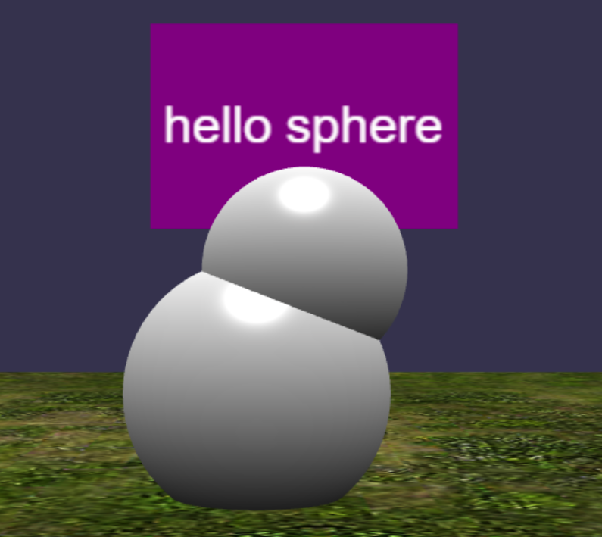

## Observables (Collision)

**app.ts**

Add the following codes:

//use observables (@ Can be shifted to hello-mesh.ts class)

    //1. create an observable for detecting intersections

    const onIntersectObservable = new Observable<boolean>()

    scene.registerBeforeRender(function(){

      const isIntersecting = sphere.intersectsMesh(helloSphere, true, true)

      onIntersectObservable.notifyObservers(isIntersecting)

    })

    helloSphere.onInterectObservable = onIntersectObservable

    const redColor = Color3.Red()

    const whiteColor = Color3.White()

    helloSphere.onInterectObservable.add(isIntersecting => {

      const material = helloSphere.mesh.material as StandardMaterial

      const isRed = material.diffuseColor === redColor

      if(isIntersecting && !isRed)

      {

        material.diffuseColor = redColor

      }

      else if(!isIntersecting && isRed)

      {

        material.diffuseColor = whiteColor

      }

    })

Here:

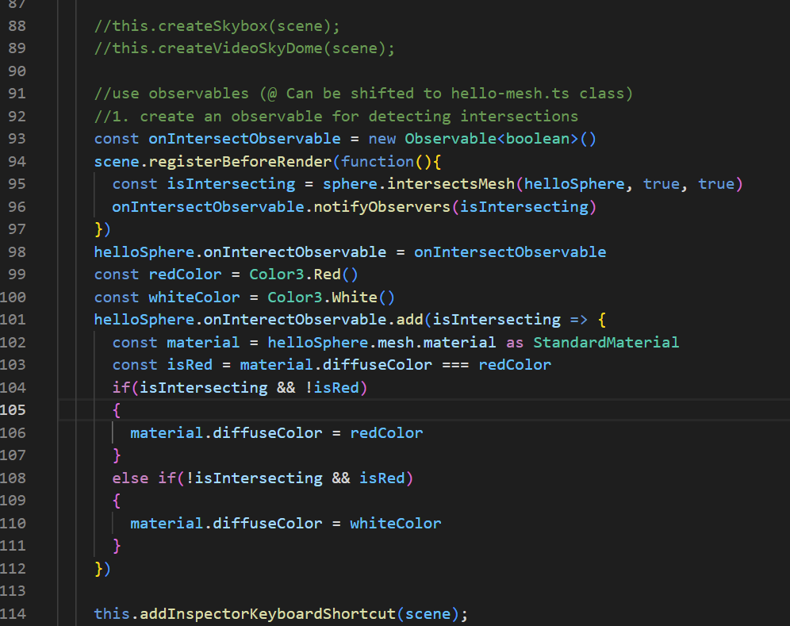

**hello-mesh.ts**

Add the following codes:

onInterectObservable: Observable<boolean>

Here:

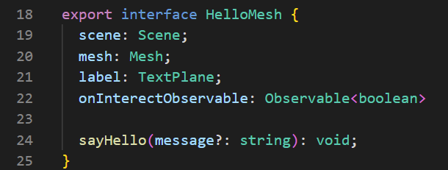

Here:

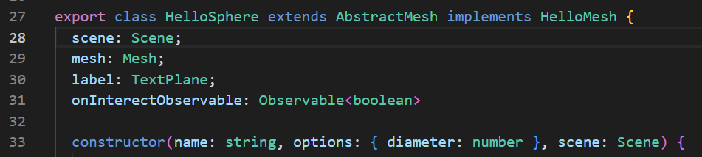

**Check**

When you drag the “helloSphere” Object to collide with the “sphere” Object, the “helloSphere” Object will turn into a Red wireframe Sphere.

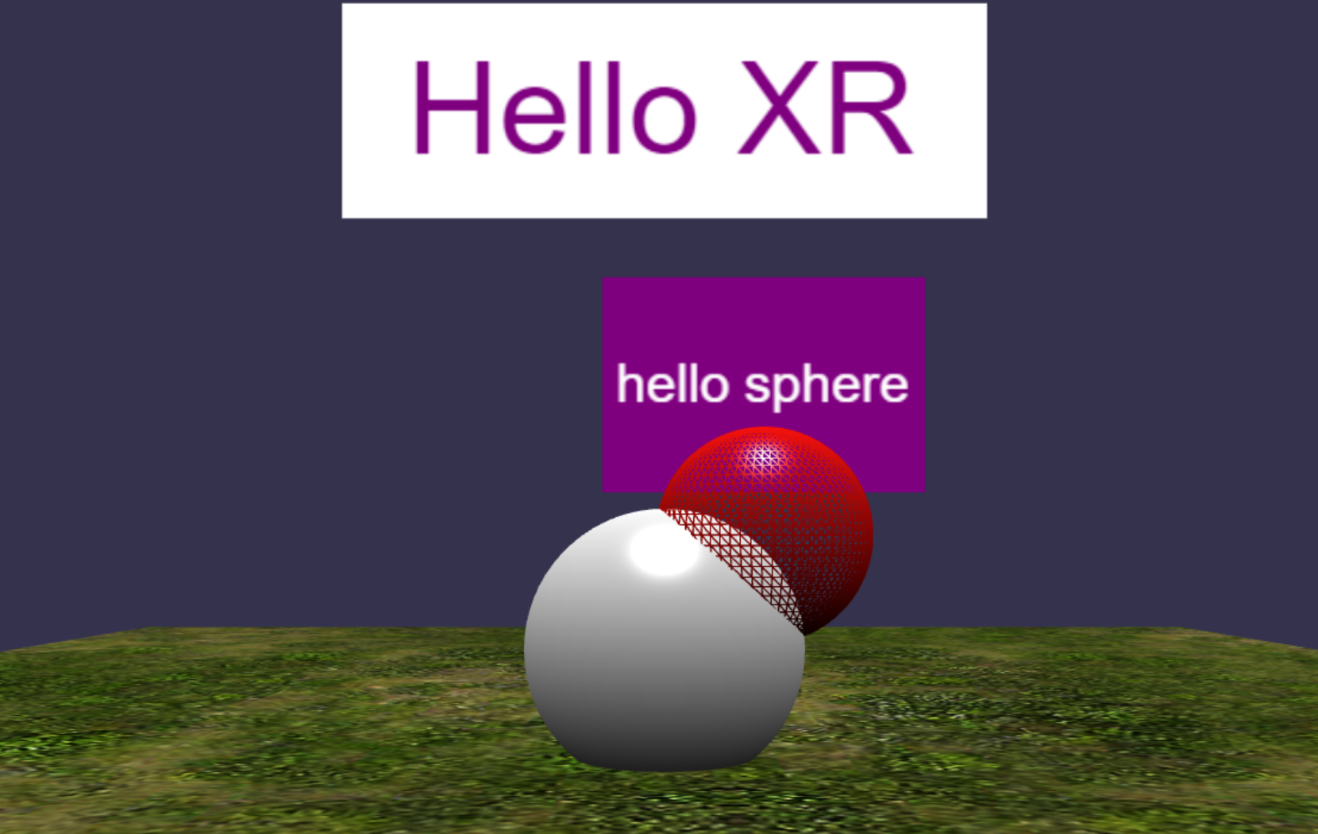

## Observables (Collision checking distance)

**app.ts**

Add the following codes:

//2. create an observable for check distance

    const onDistanceChangeObservable = new Observable<number>();

    let previousState: number = null;

    scene.onBeforeRenderObservable.add(() => {

      const currentState = Vector3.Distance(

        sphere.position,

        helloSphere.position

      );

      if (currentState !== previousState) {

        console.log("distance updated!");

        previousState = currentState;

        onDistanceChangeObservable.notifyObservers(currentState);

      }

    });

    helloSphere.onDistanceChangeObservable = onDistanceChangeObservable;

    const blueColor = Color3.Blue();

    helloSphere.onDistanceChangeObservable.add((distance) => {

      const isCloseEnough = distance <= 1.2;

      const material = helloSphere.mesh.material as StandardMaterial;

      const isBlue = material.diffuseColor === blueColor;

      const isRed = material.diffuseColor === redColor;

      if (isCloseEnough && !isBlue && !isRed) {

        material.diffuseColor = blueColor;

      } else if (!isCloseEnough && isBlue) {

        material.diffuseColor = whiteColor;

      }

    });

Here:

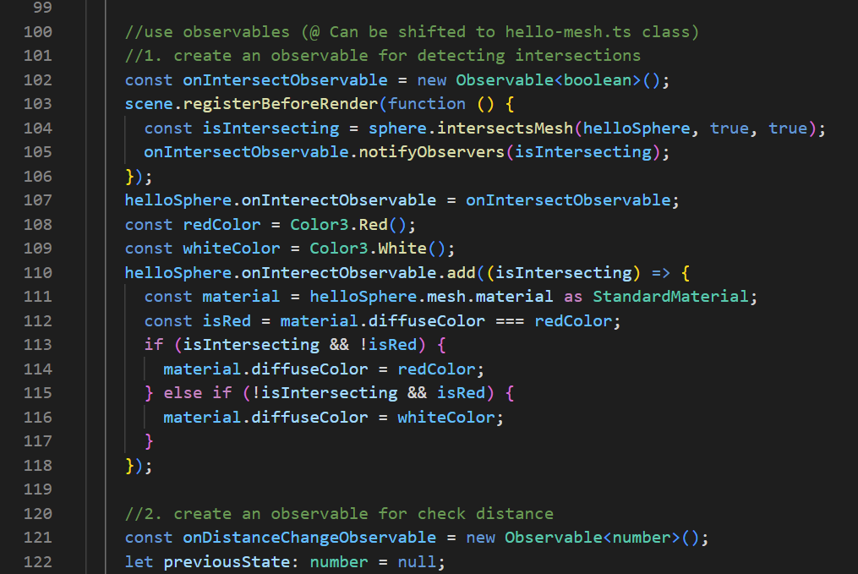

**hello-mesh.ts**

Add the following codes:

onDistanceChangeObservable: Observable<number>

Here:

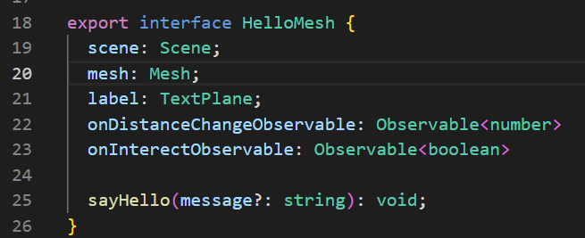

Here:

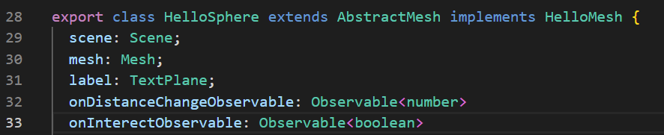

**Check**

When you drag the “helloSphere” Object to collide with the “sphere” Object, the “helloSphere” Object will first turn into a Blue wireframe Sphere.

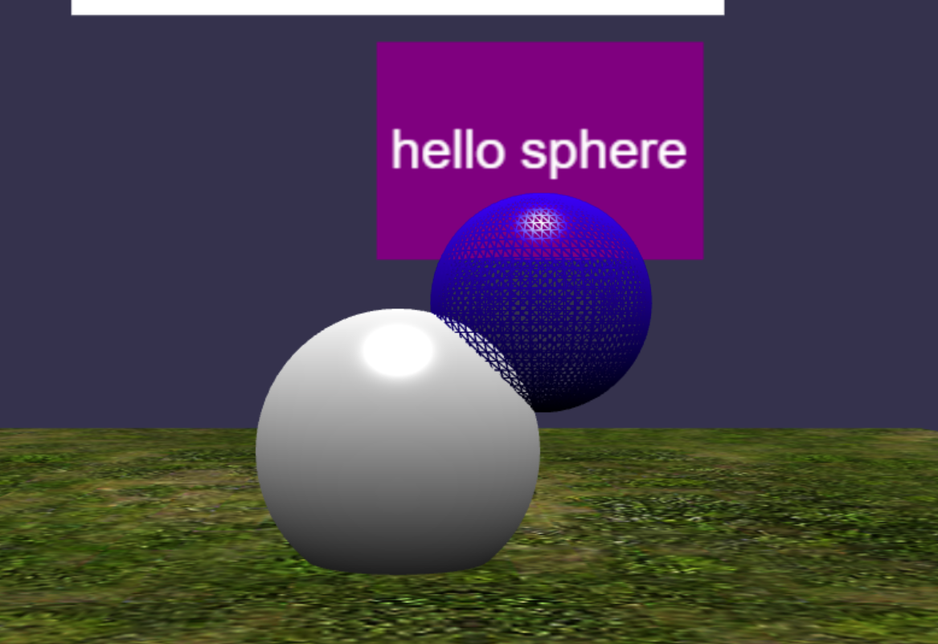

Then it will turn into a Red wireframe Sphere when the collision is further in.

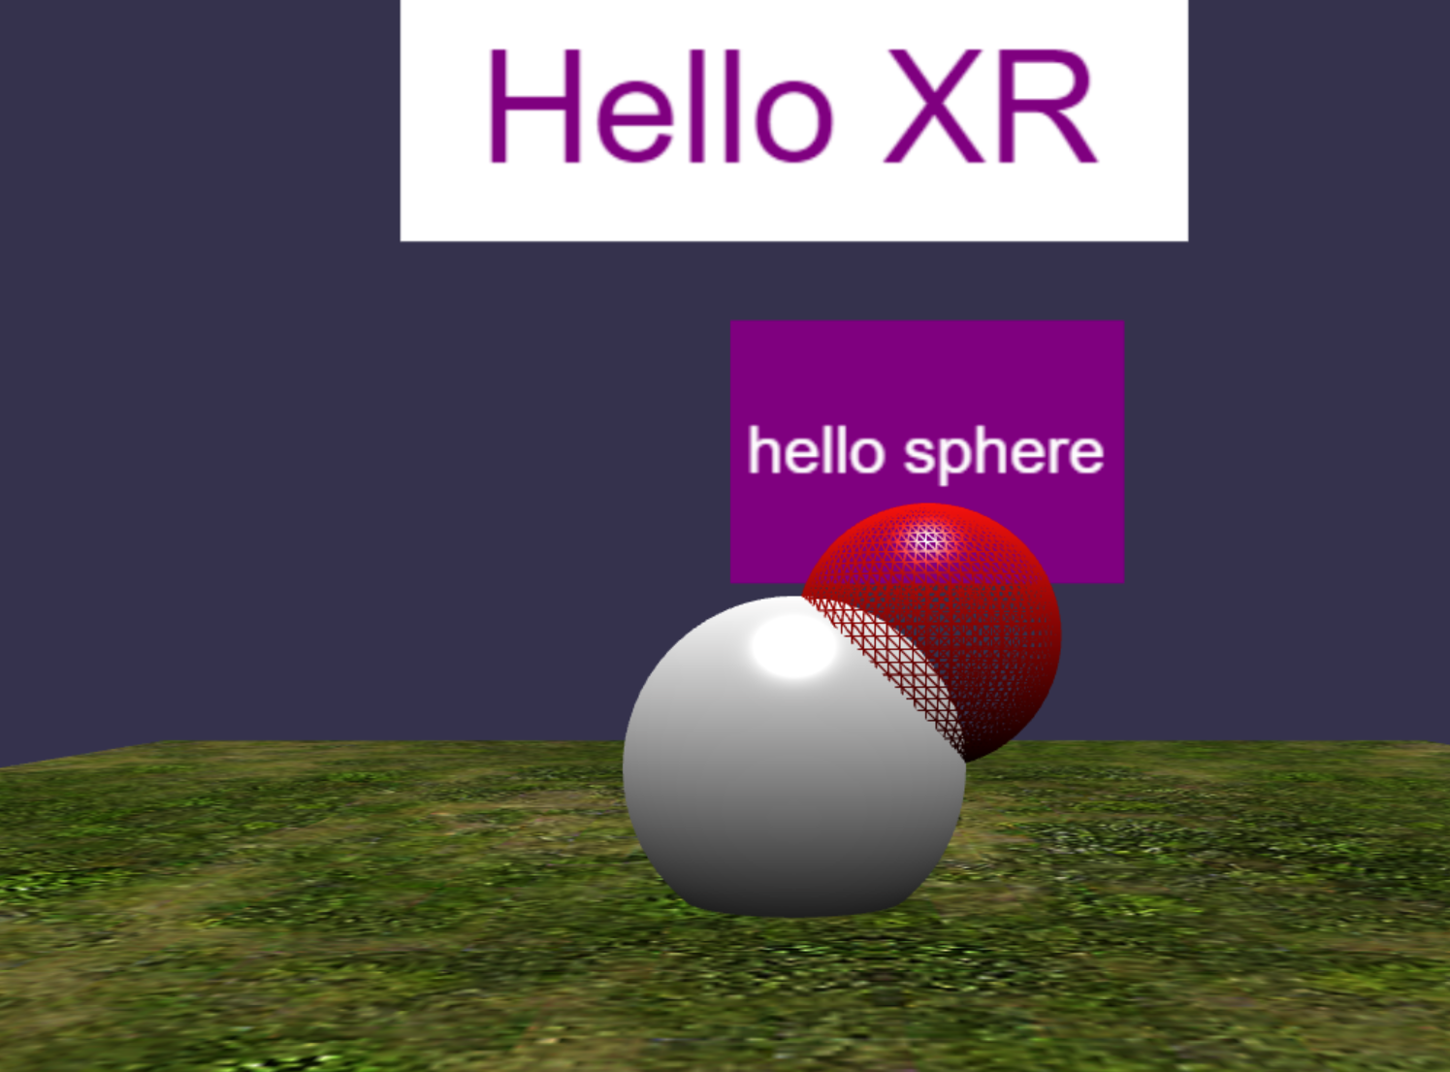

## Observables (Display distance)

**app.ts**

Add the following codes:

//3. create observer (Display distance on text block)

    const observer = new Observer<number>((distance) => {

      helloSphere.label.textBlock.text = "d: " + distance.toFixed(2)

    }, -1);

    onDistanceChangeObservable.observers.push(observer)

Here:

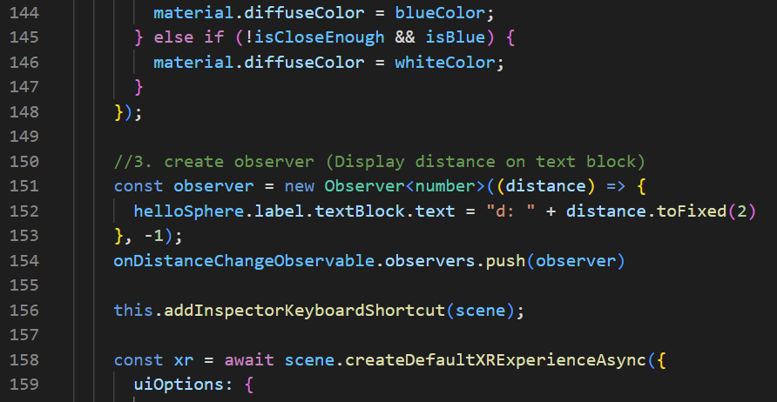

**Check**

When you drag the “helloSphere” Object around, the purple text block above the object will display the distance from the “helloSphere” Object to the “sphere” Object.

